**Analysis on fund_manager**

*# fund manager with highest returns in 5 years*

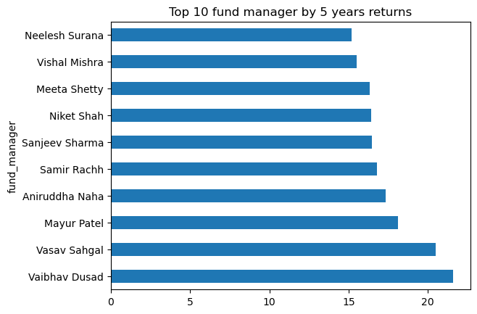

*# category wise, top 5 fund manager with avg highest returns*

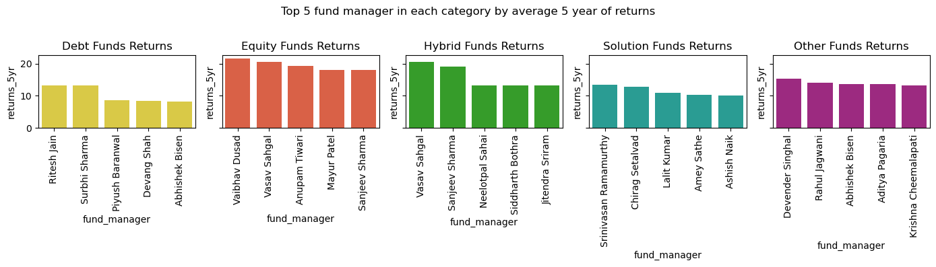

Conclusion

* There are 3 fund manager in Debt Funds having higher returns among top 5 fund manager.
* In the Equity category Vaibhav Dusad has managed to give highest returns.
* In the Hybrid category Vasav Sahgal has managed to give highest returns.
* In the Solution Funds category Srinivasan Ramamurthy has managed to give highest returns.
* In the Other Funds category Devender Singhal has managed to give highest returns.
* *# top 10 fund manager by the number of schemes*

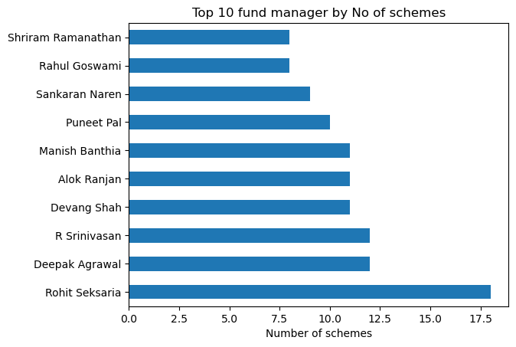

Conclusion

* Rohit Seksaria is managing the highest number of Funds.
* *# top 10 fund manager by the mean age of funds*

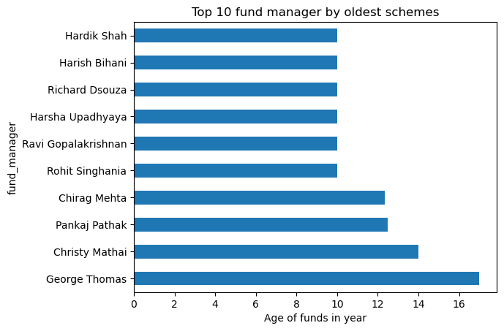

Conclusion

* George Thomas is managing a fund which is the oldest among our dataset.
* *# top 10 fund manager by the assets under management*

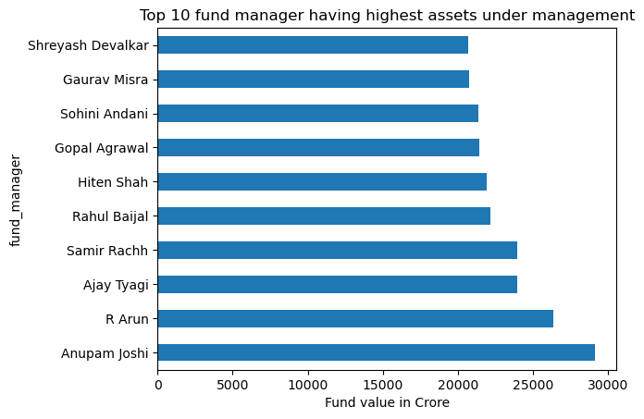

Conclusion

* Anupam Joshi has the highest AUM.

## Analysis on min_sip and min_lumpsum

*# distribution of min_sip*

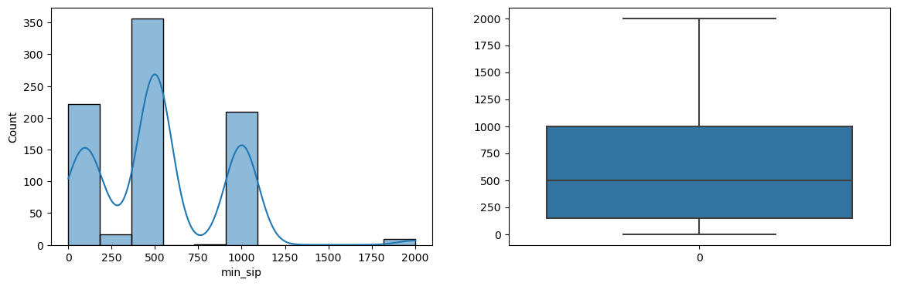

Conclusion

* Most of the funds have Minimum SIP amount as 0,500 and 1000
* *# distribution of min_lumpsum*

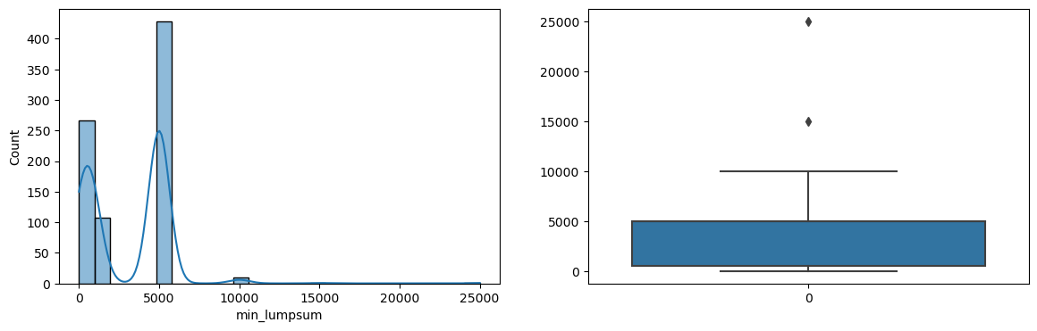

Conclusion

* Most of the funds have Minimum Lumpsum amount between 0 to 5000
* *# distribution of min_sip and min_lumpsum by category type*

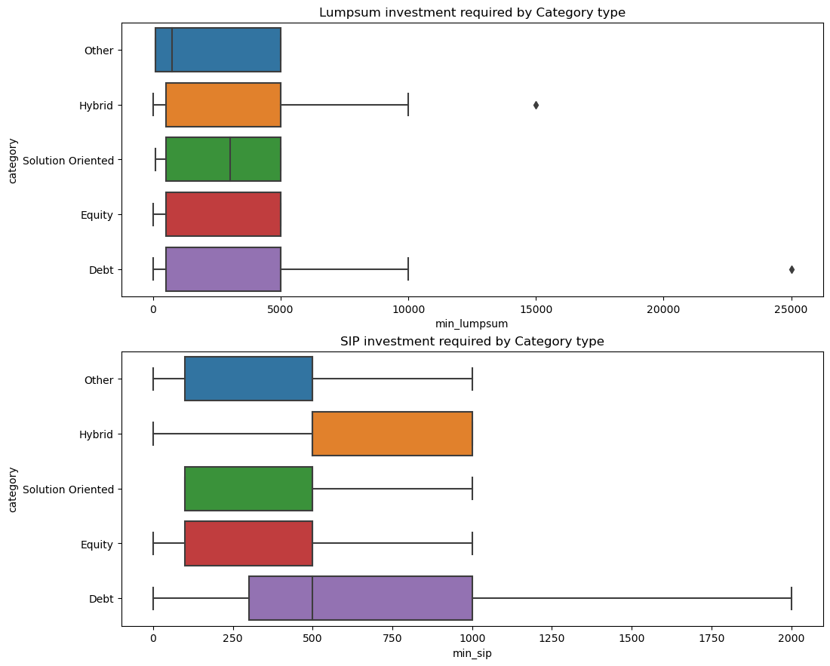

Conclusion

* Across fund type lumpum investment is almost same.
* Across fund type sip investment is high among Hybrid and Debt funds.

*# distribution of min_sip,min_lumpsum by sub_category type*

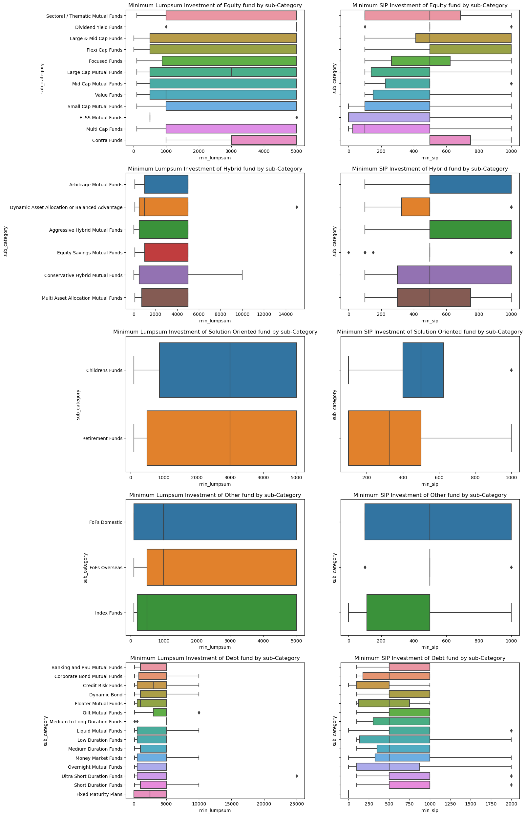

## Analysis on expense ratio

* The expense ratio measures how much of a fund's assets are used for administrative and other operating expenses.
* A mutual fund expense ratio that is at or below its peer average is ideal.

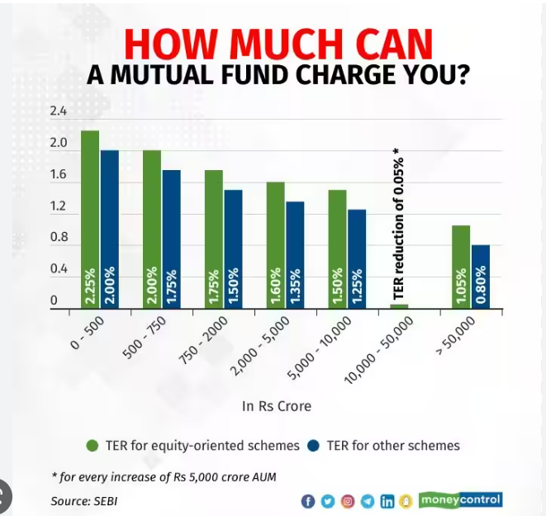

*# expense ratio variation with fund size group across different category*

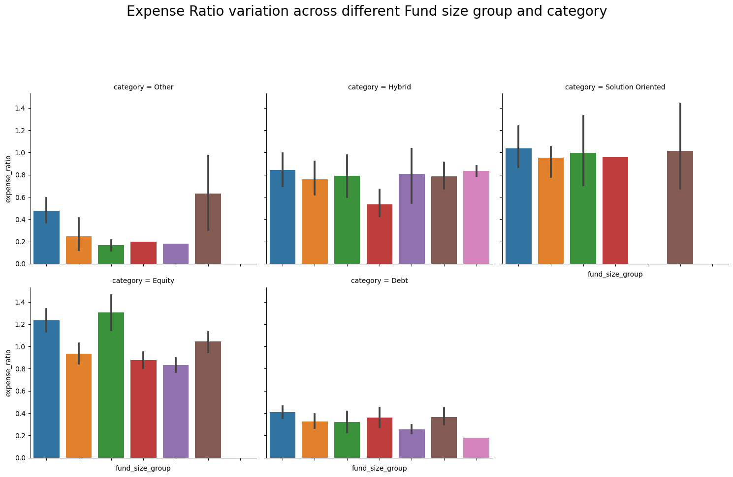

Findings:

* Large fund size does have low expense ratio.
* Debt has the lowest 'expense ratio' amongs the funds.

*# expense ratio distribution*

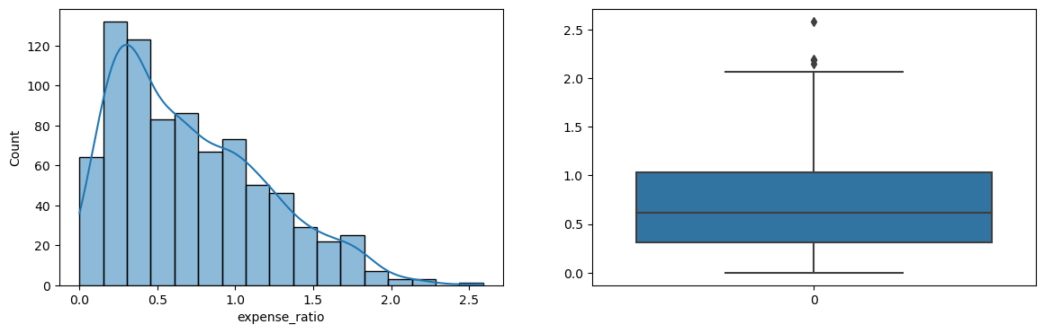

Conclusion

* Expense ratio of most of the schemes lies between 0 to 1

*# distribution of expense ratio by category type*

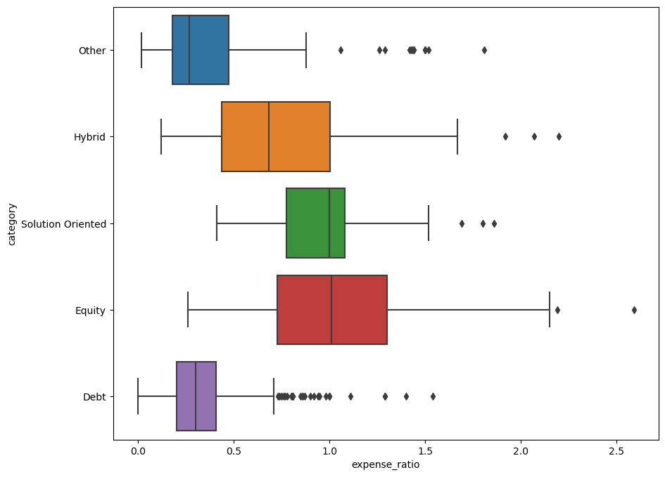

Conclusion

* Equity and Solution oriented funds have the highest expense ratio among funds.
* *# distribution of expense ratio by sub-category type*

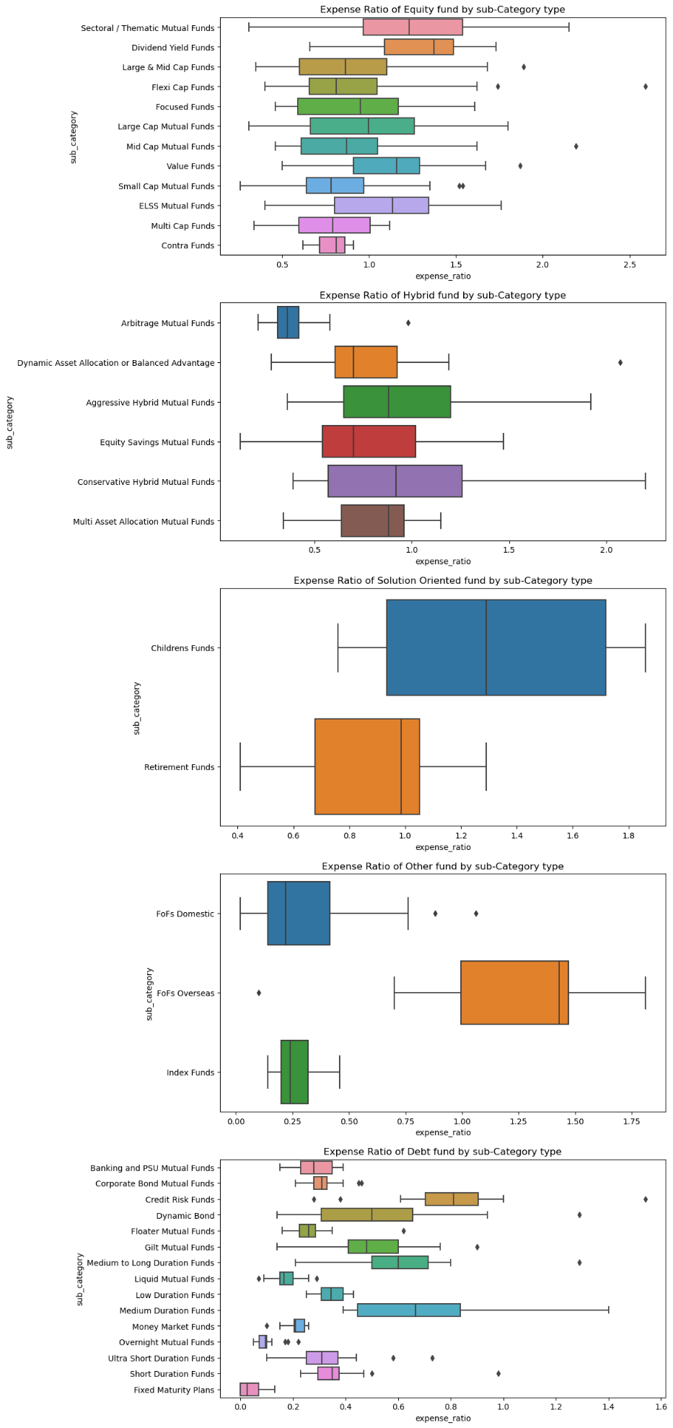

Conclusion

Equity type -

* Among equity type Sectoral and Dividend Yield funds have the highest expense ratio.

Hybrid type-

* Among hybrid type Arbitrage Funds have the Lowest expense ratio.

Solution Oriented -

* Chilren Funds have the highest expense ratio.

Other Fund-

* FOFs Overseas has the highest expense Ratio.

Debt Fund-

* Among debt fund Credit Risk Funds has the highest expense ratio.

*# expense ratio vs rating*

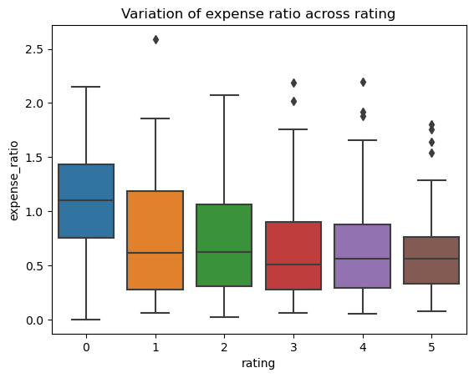

Findings -

* For higher rating funds, expense ratio is less.
* We will check category distribution with rating to learn more.
* *# Lets find why 0 rating fund has high expense ratio*

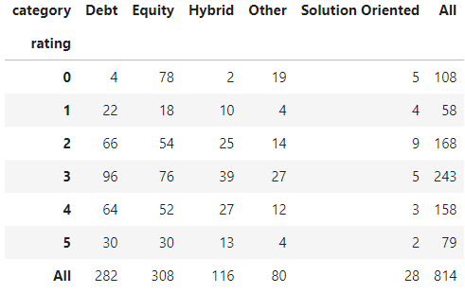

Findings

* Clearly 0 rating fund has more equity category=72% and equity fund has high expense ratio.
* *# expense ratio vs risk level*

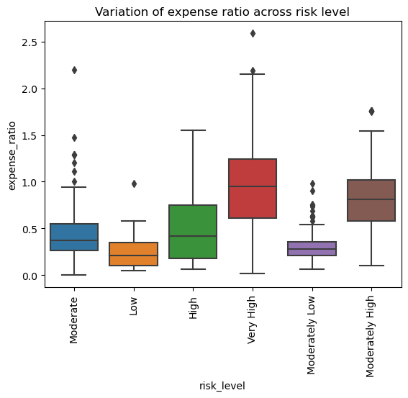

Conclusion

* Expense ratio is high for very high risk. We can check which category mostly falls in high risk as it has to be Equity.
* *# Lets find why very high risk fund has high expense ratio*

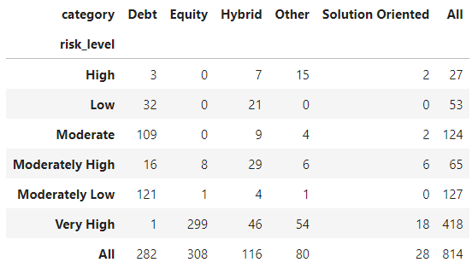

Findings

* Most of the Very high risk funds are from Equity and equity fund has high expense ratio.

## Analysis on fund size

*# distribution of fund size*

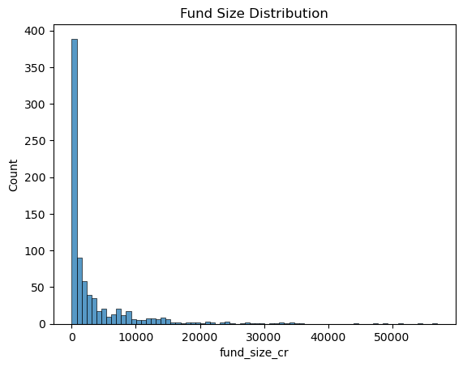

Findings

* Most of the fund size is less than 2000 Cr.
* *# fund size across fund age*

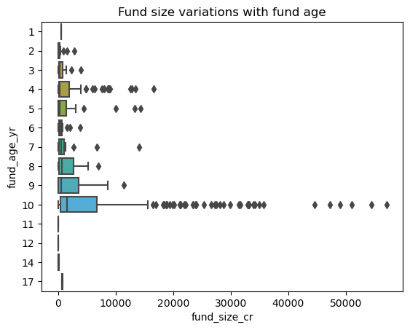

Conclusion

* 10 years old fund has maximum fund size
* *# fund size vs rating*

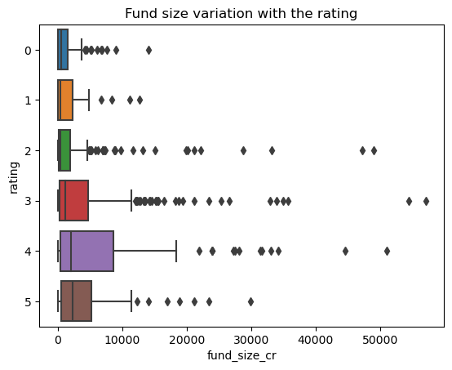

Conclusion

* People seems to be interested in investing higher rated funds. We will see if ratings have any impact on returns in further slides.
* *# fund size vs risk level*

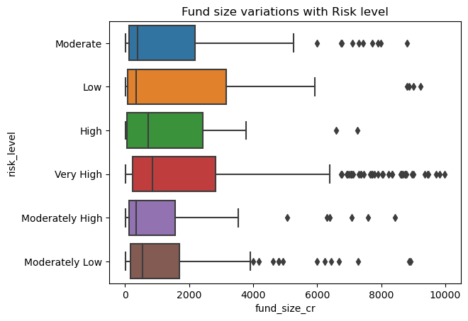

Conclusion

* Most of the funds are invested in risk level High and Very High
* *# top 10 AMC by sum of funds managed*

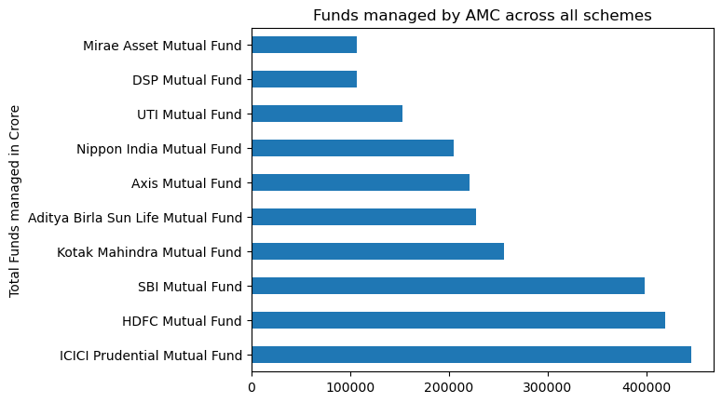

Conlusion:

* ICICI Prudential Mutual Fund has received the highest funds collectively. (Popular AMC)
* *# category wise fund*

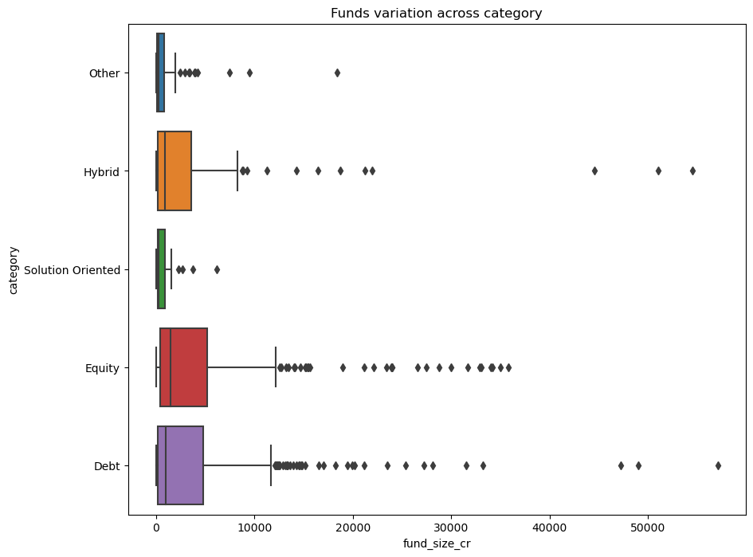

Conlusion

* Most of the funds are invested in Equity funds. (Popular category Debt and Equity)
* *# sub category wise fund*

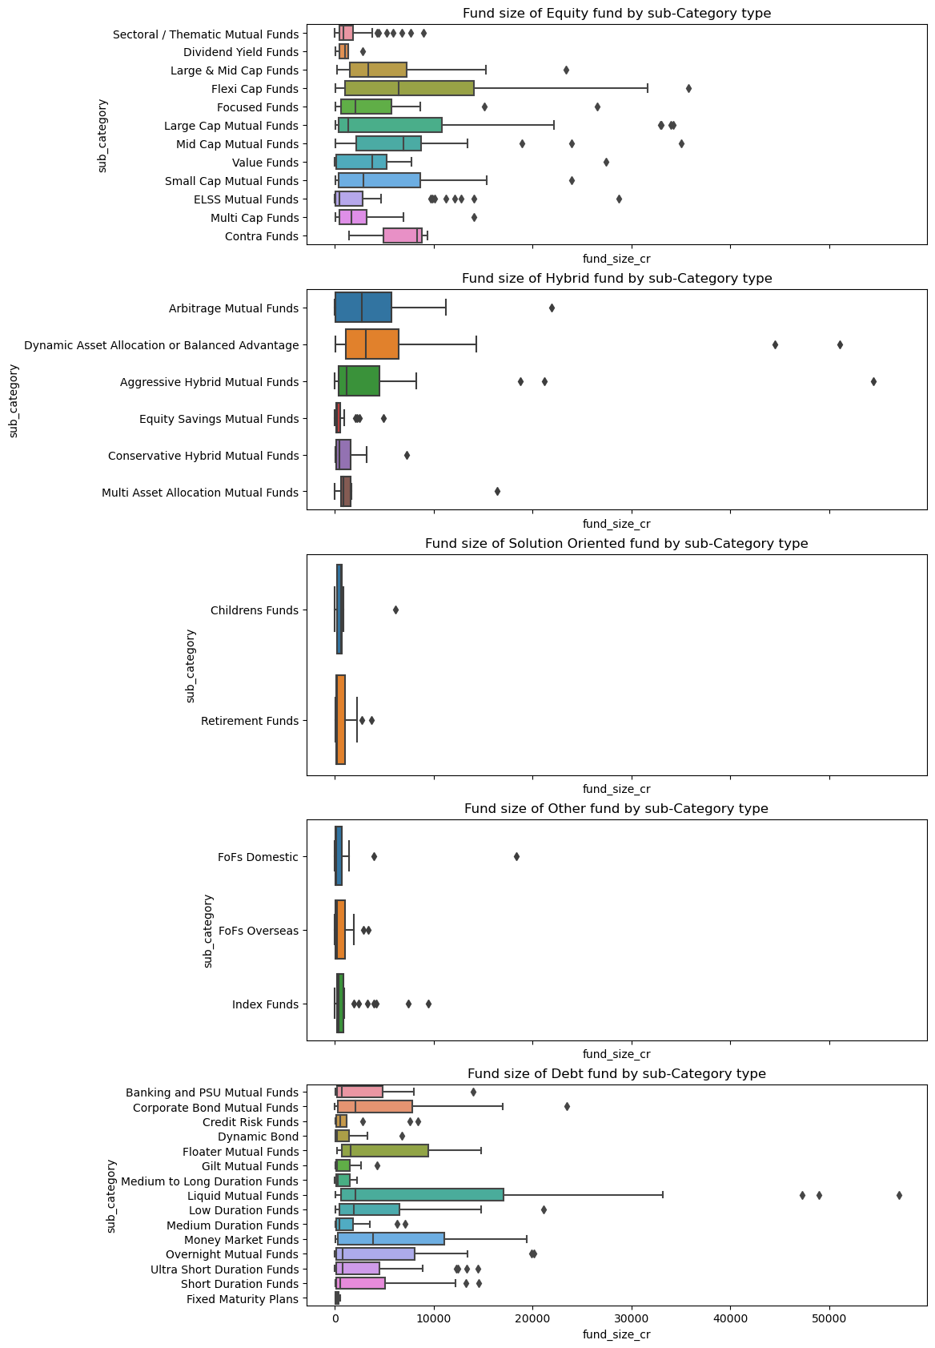

Conclusion

Equity-

* Mid cap, Flexi Cap and Contra get more funds. (Popular Sub-category in Equity)

Hybrid-

* Balanced and Arbitrage get more funds. (Popular Sub-category in Hybrid)

Debt-

* Money market and Liquid mutual funds get more funds. (Popular Sub-category in Debt)
* *# schemes with high fund also has high returns (schemes giving higher returns will lead to funds inflow)*

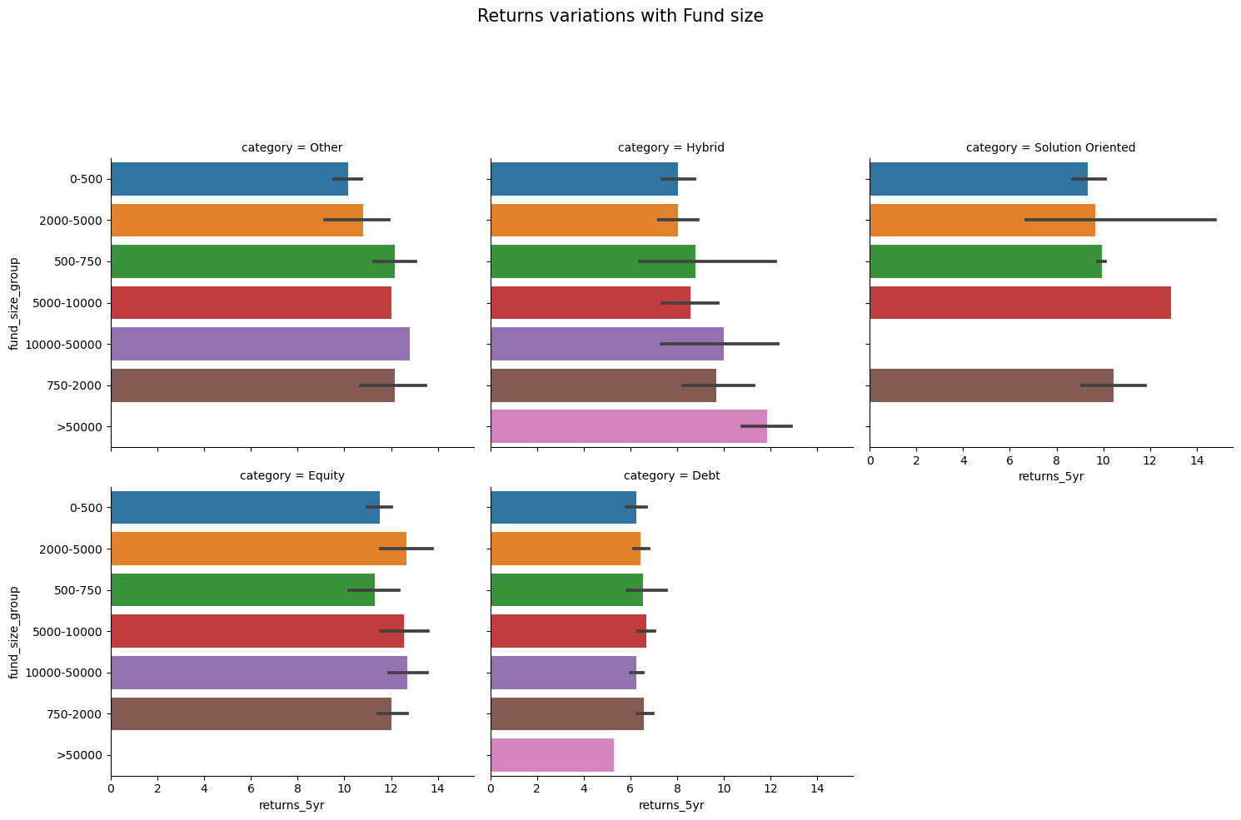

Conclusion

* Except Debt category all other are funds returns are related to fund size.
* We found that as fund size increases expense ratio decreases

## Analysis on fund age

*# distribution of fund age*

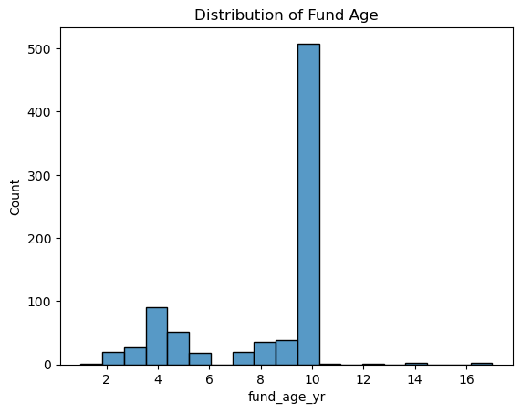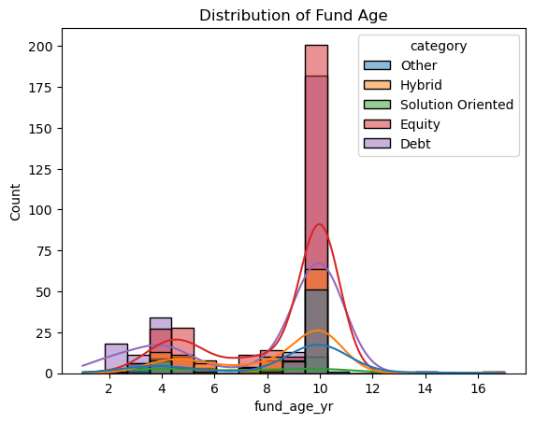  
Findings

* Recent funds are mostly Debt funds
* More than 4 year age funds are Equity type followed by Debt.
* *# can we say that new funds give better returns ?*

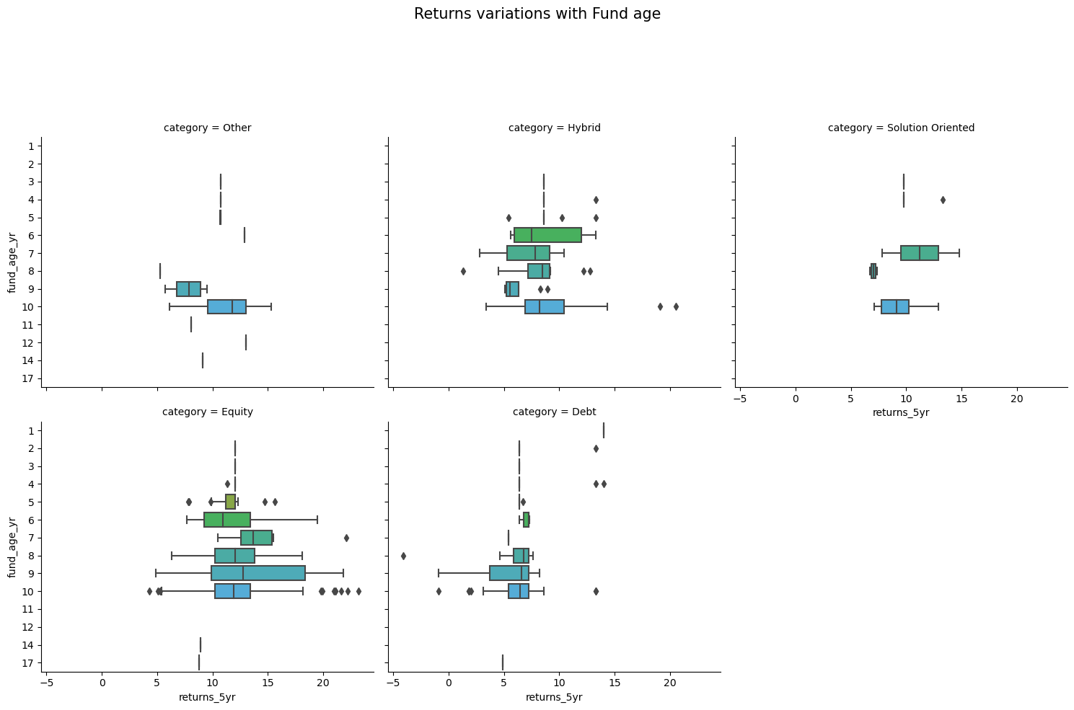

Conclusion

* It seems there is no dependency of returns on fund age. Though older funds have more data which we can analyse before investing.

## Analysis on risk level

*# total no of schemes in each risk level*

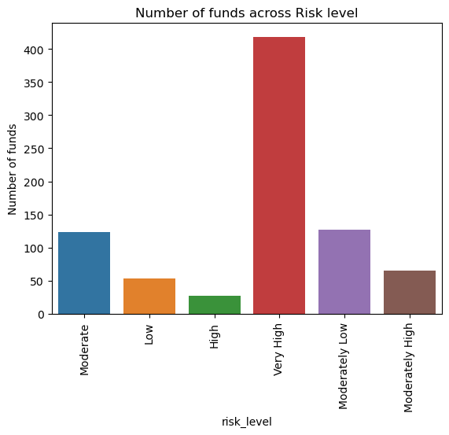

Conclusion

* Most of the schemes have risk level Very High
* *# amc and risk level*

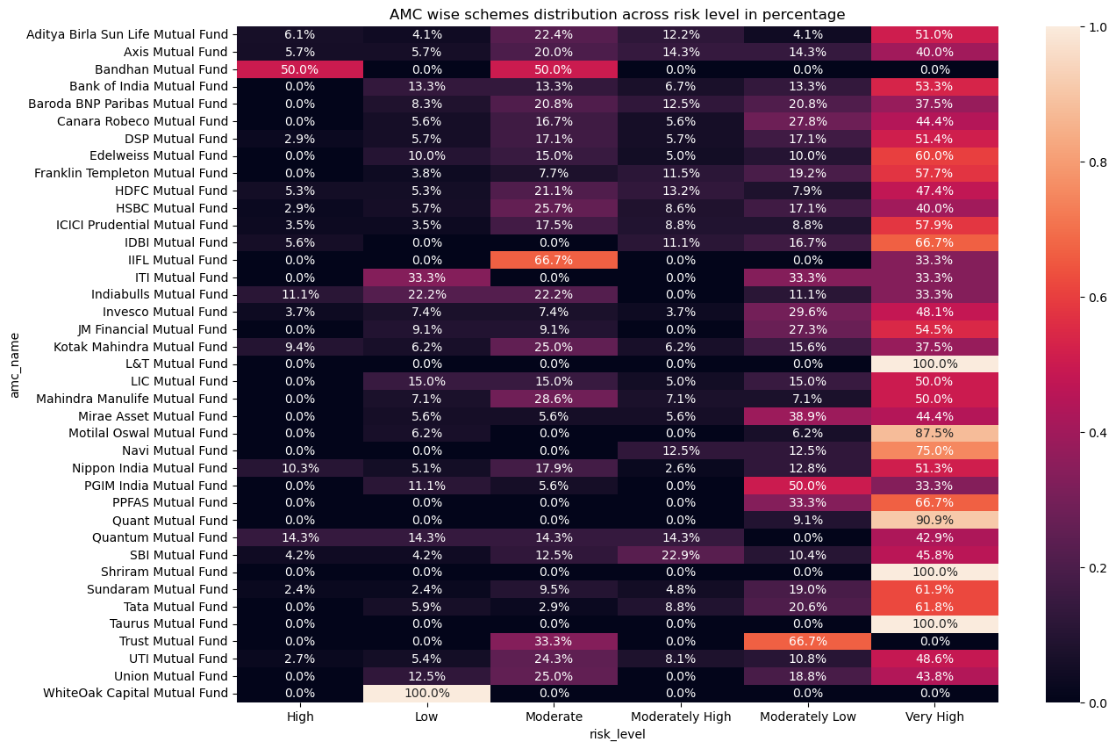

Conclusion

* Most of the AMCs have schemes with risk level 6(Very High).
* Taurus, Shriram and L&T have 100% in Very High Risk category.
* *# category and risk level*

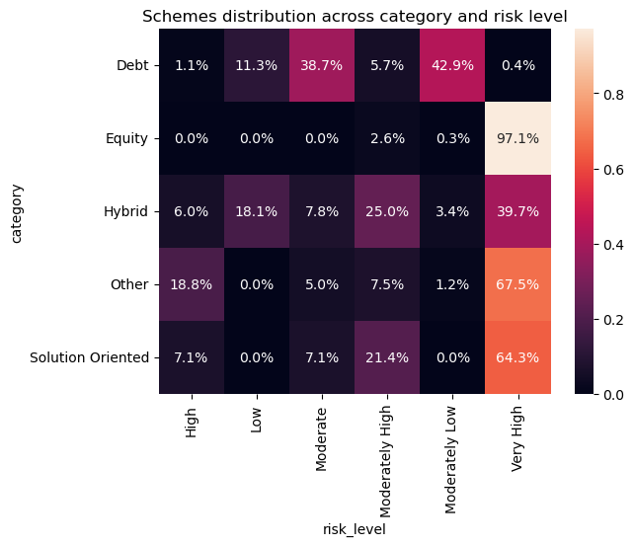

Findings

* Low, Moderate and Moderately Low are dominated by Debt Funds
* Moderately High, High and very High are dominated by Equity Funds
* *# rating and risk level*

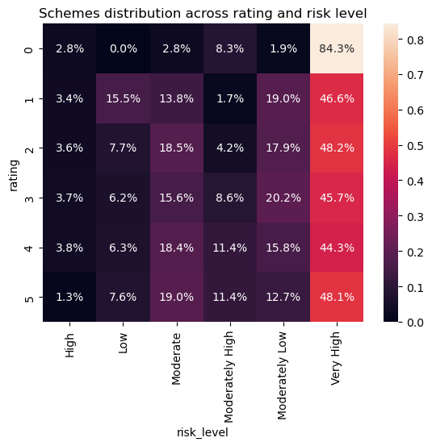

Findings -

* 0 rating funds have major concentration of Very High risk funds.

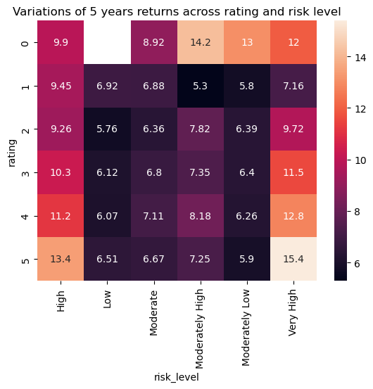

Findings -

* 0 rating funds has high return as in the above cell you can see most 0 rated funds are in equity.
* For risk level 5 and 6 as high rated fund should be chosen as returns are 13.4% and 15.4% respectively.
* *# high risk level means high returns ??*

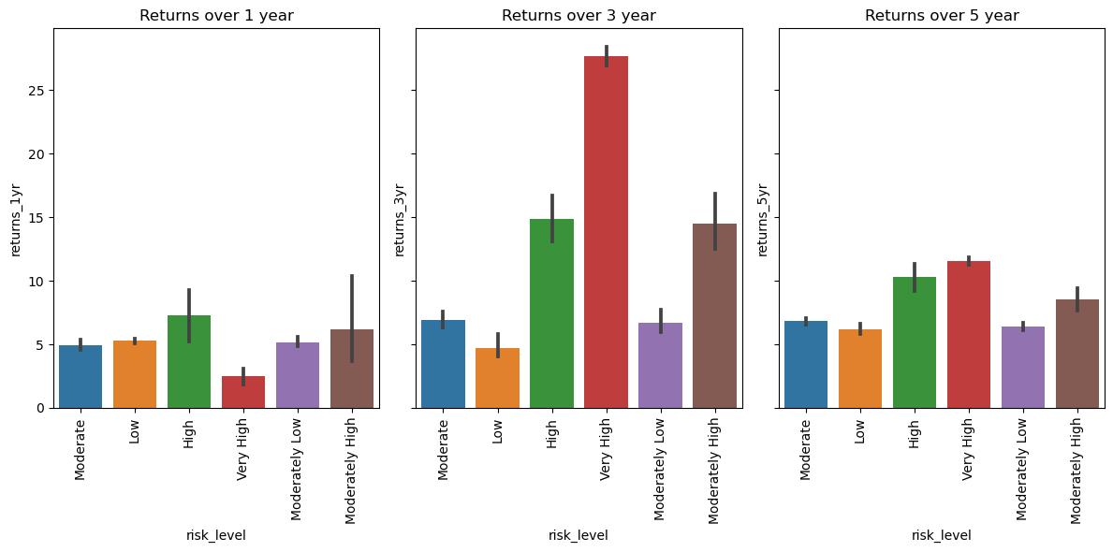

Findings -

* In 3 and 5 years returns have a positive relation with risk level.
* It clearly shows that high risk funds should be held for longer time to get more returns.

## Analysis on AMC

*# distribution of amc*

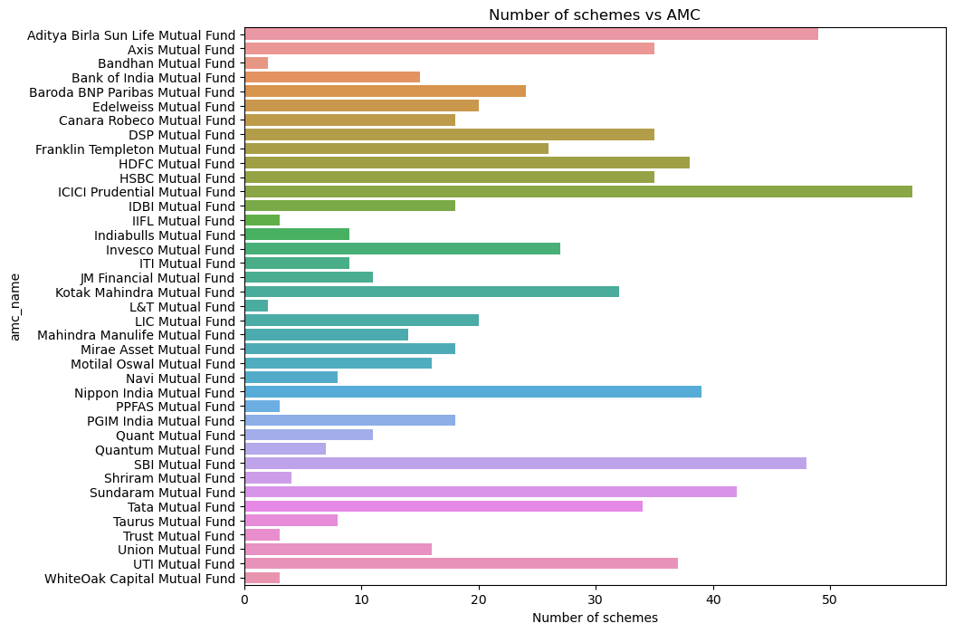

Findings- ICICI has around 57 schemes running

*# avg rating of amc funds*

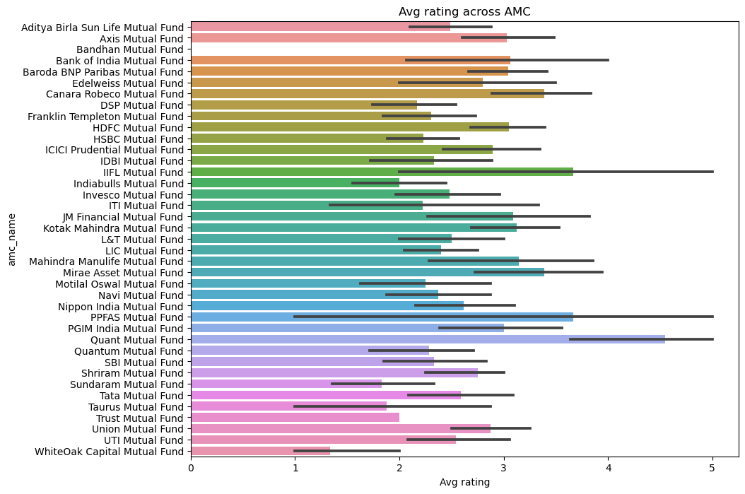

Findings - Quant Mutual Funds have the highest rating.

*# amc name vs category*

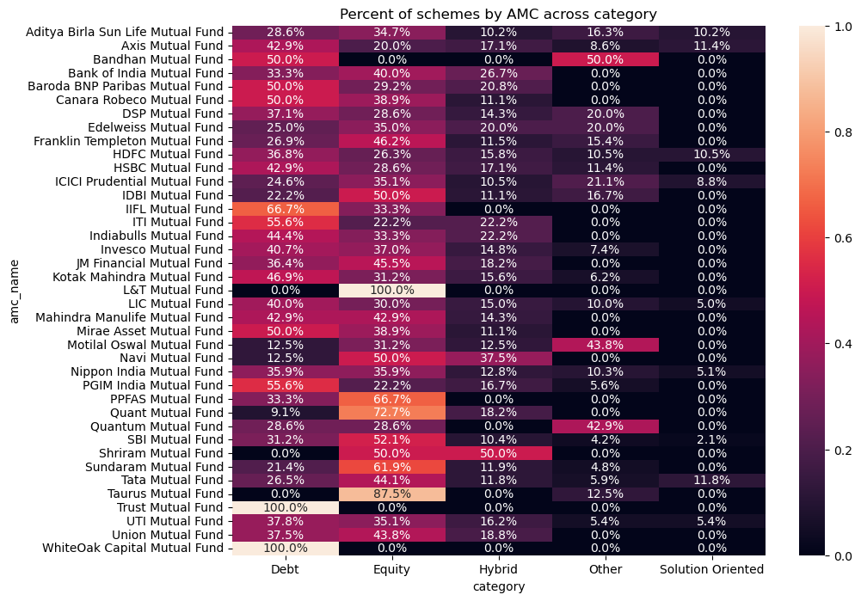

Findings -

* Most of the AMC have funds in Debt and Equity category.

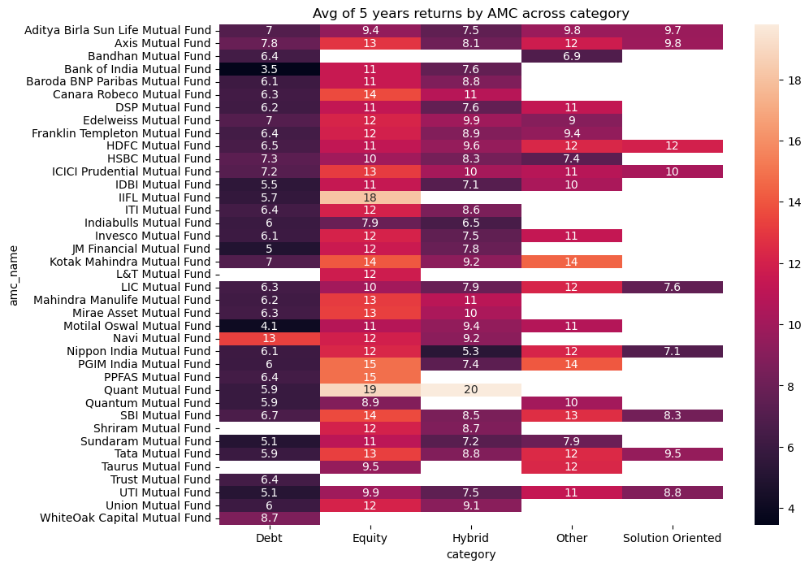

Findings-

* Highest return of 13% in debt category is given by Navi Mutual Fund. (Though there was 1 debt fund by Navi)
* Highest return of 19% in Equity category is given by Quant Mutual Fund.
* Highest Return of 20% in Hybrid category is given by Quant Mutual Fund.
* *# amc name vs sub-category*

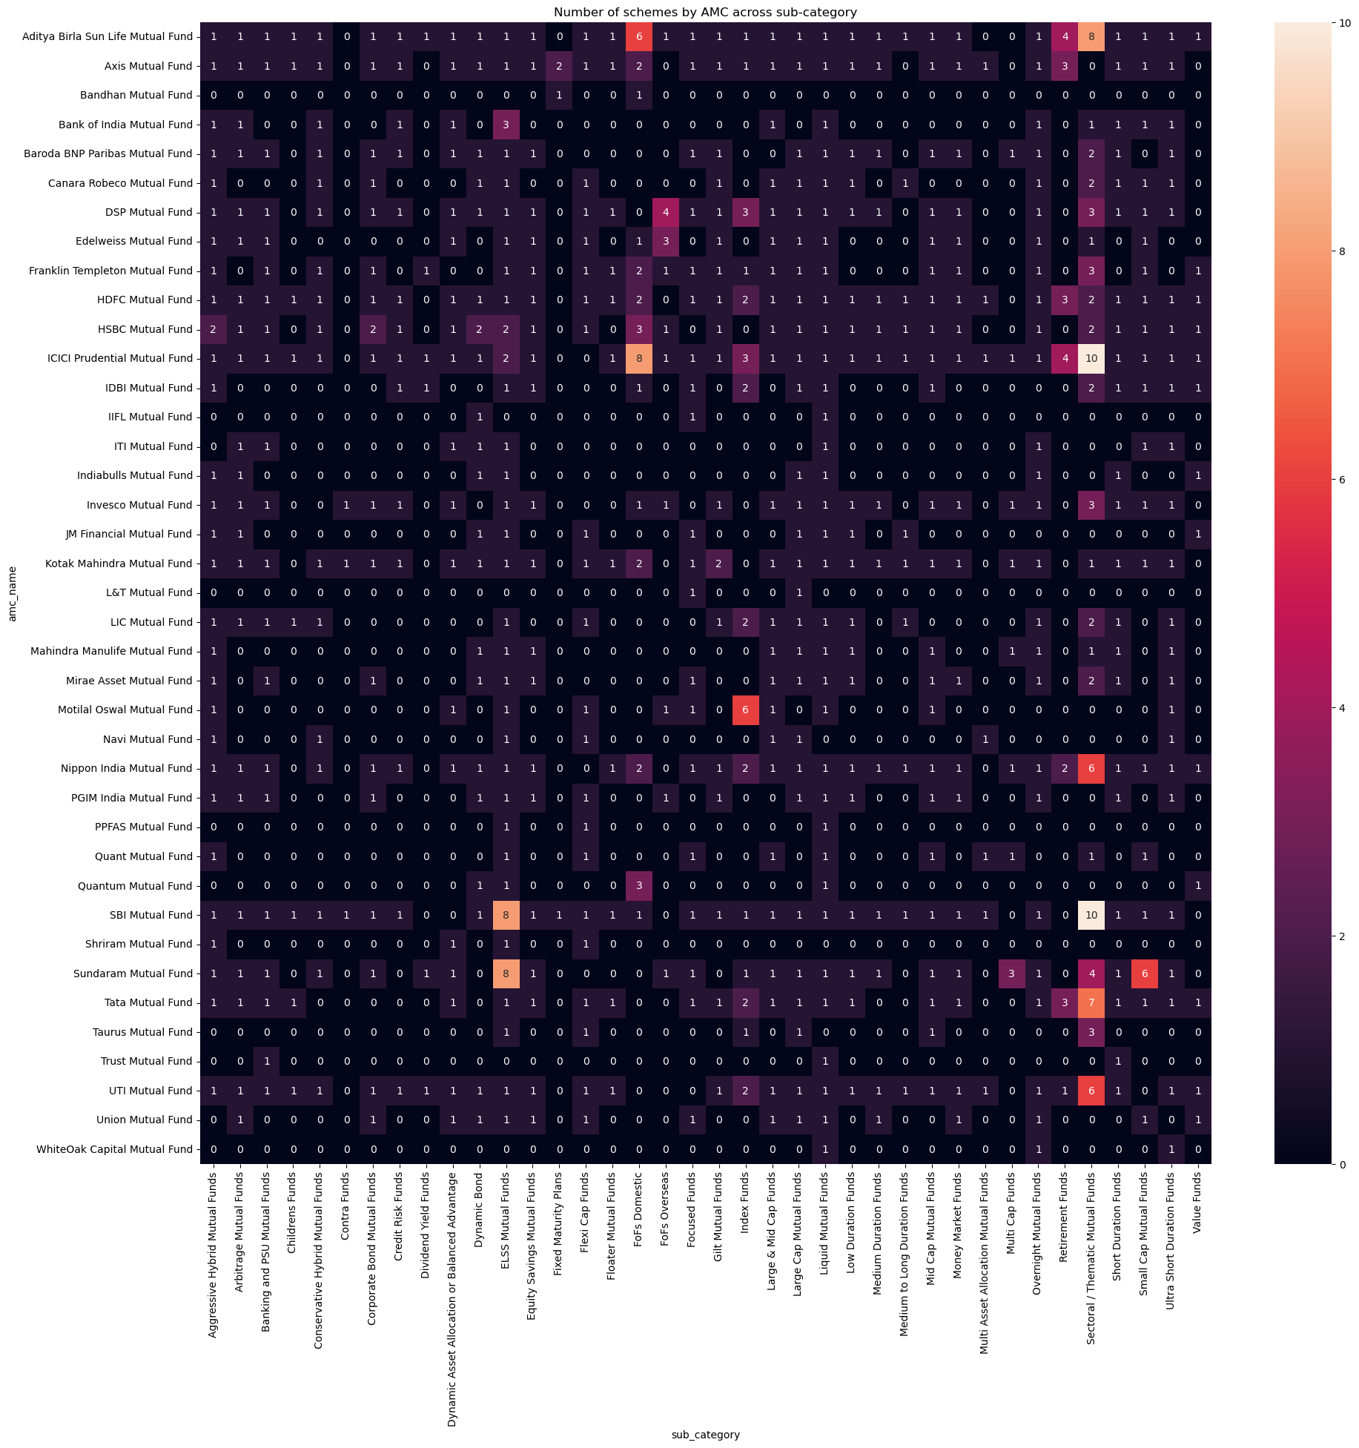

Findings

* Most of schemes are opened in Sectoral/Thematic sub category.
* 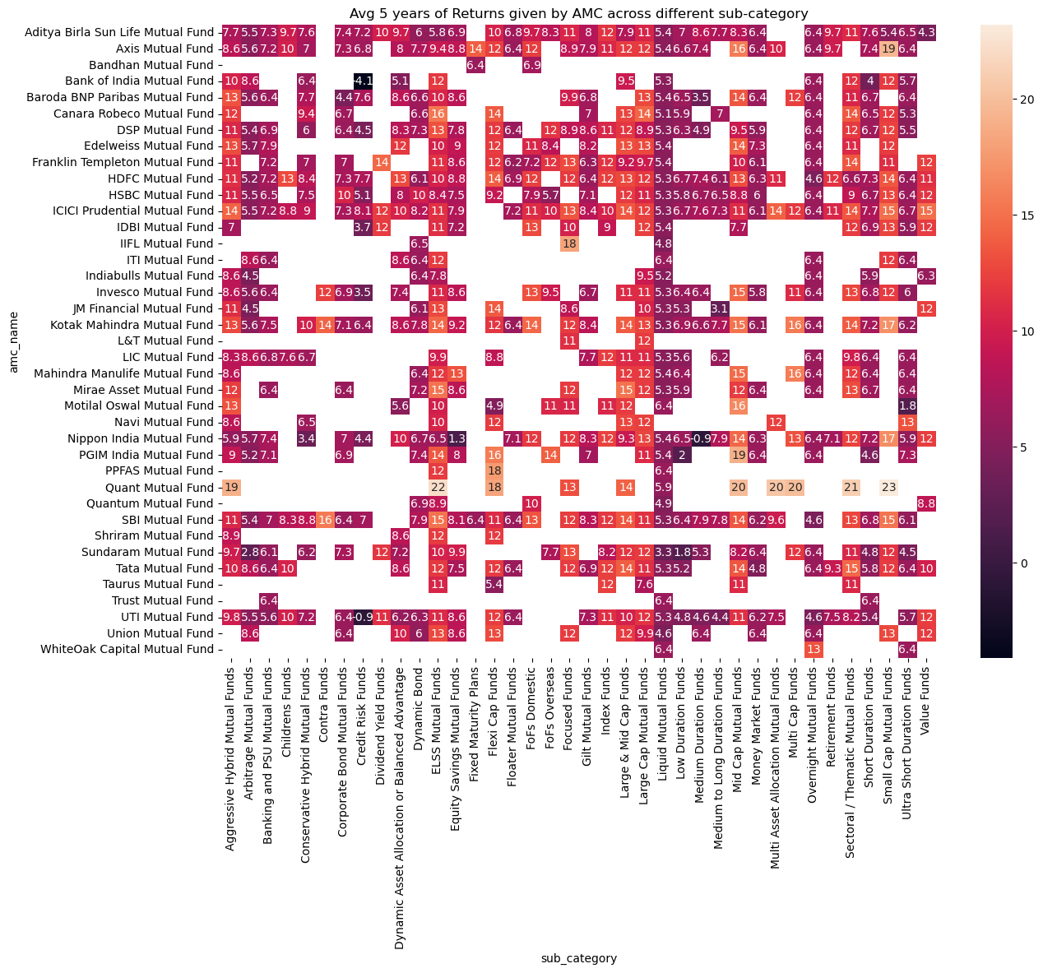
* Findings - Quant Mutual Funds have performed very well across different Sub categories.

## Analysis of Rating

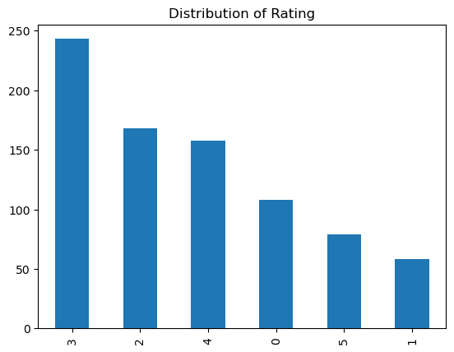

*# does returns vary because of ratings ??*

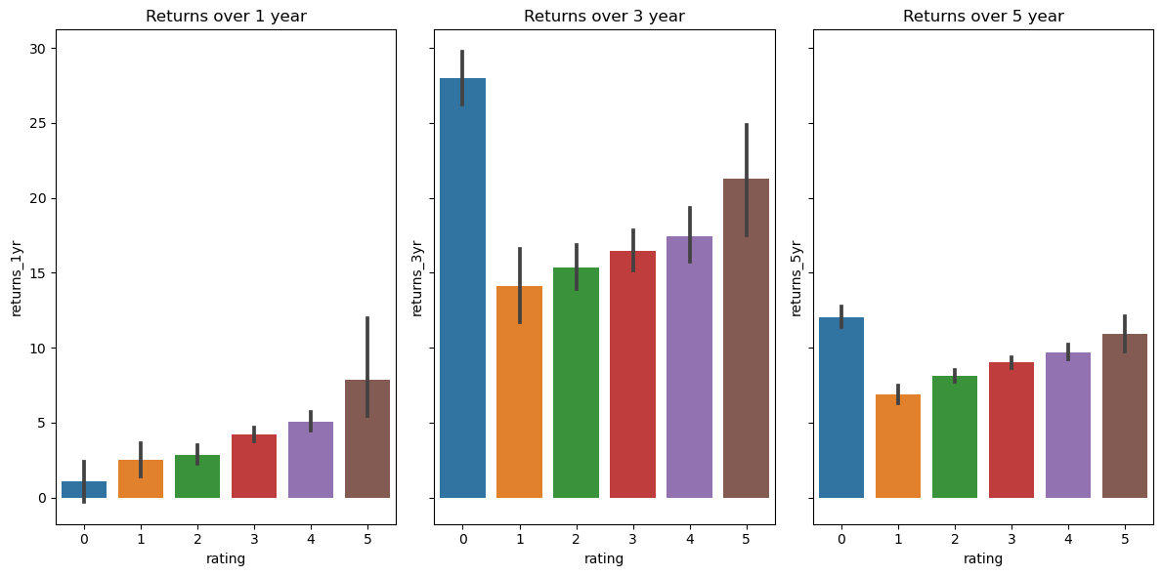

Findings -

* Except for 0 rating there is direct correlation in returns. As only in 0 rating, Equity funds are more than Debt funds
* Leaving 0 rating category, we can say that higher the rating higher returns.
* *# lets check why 0 rating is giving higher returns*

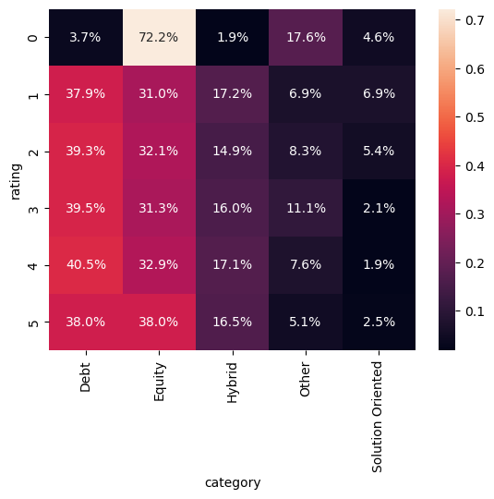

Findings

* Equity constitutes 72% in 0 rating
* Other ratings has somewhat equal distribution.

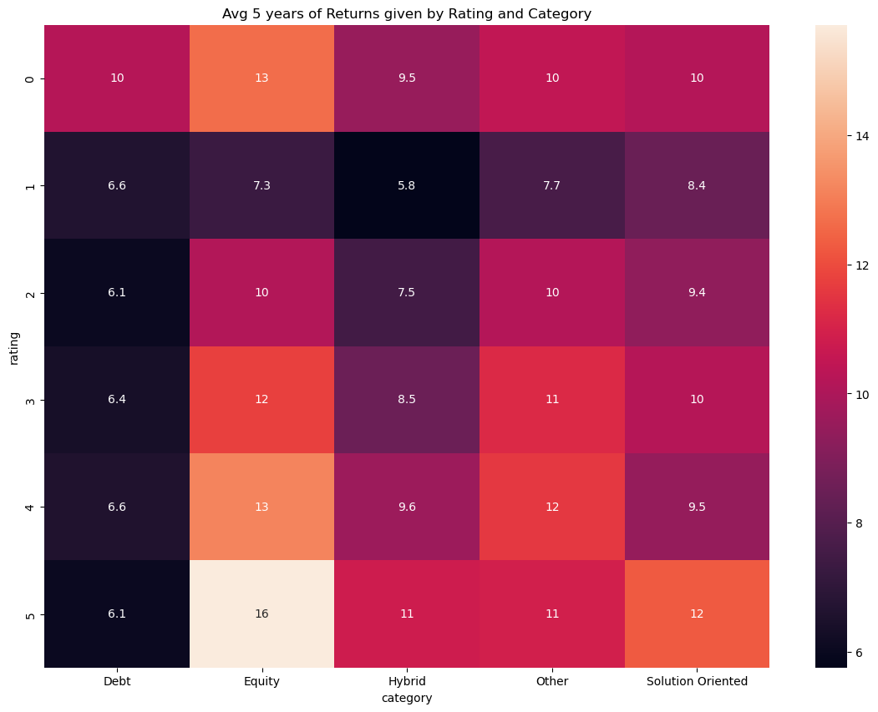

Findings

* Leaving 0 rating category, we can say that higher the rating higher returns.

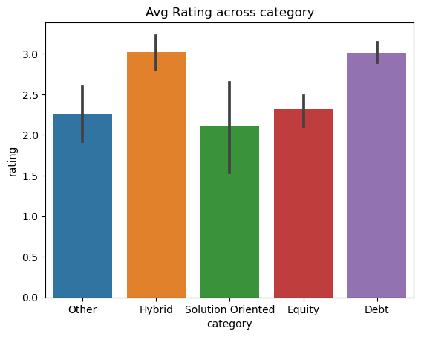

## Analysis on category

*# distribution of category*

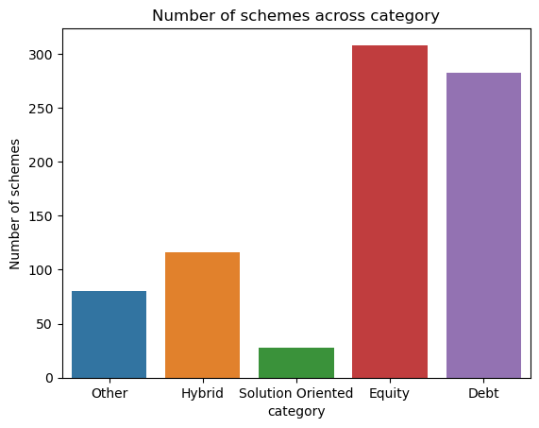

Findings - Among category most of the schemes are Equity or Debt type

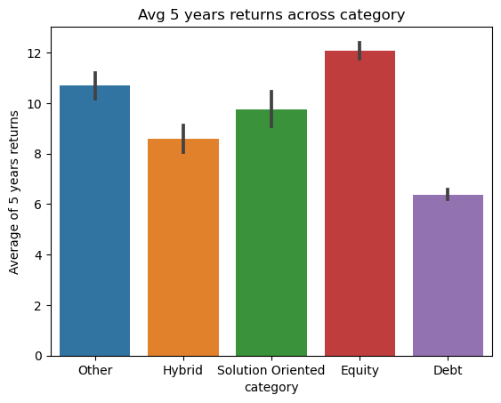

Findings - Equity has given highest return

*# sub category vs category*

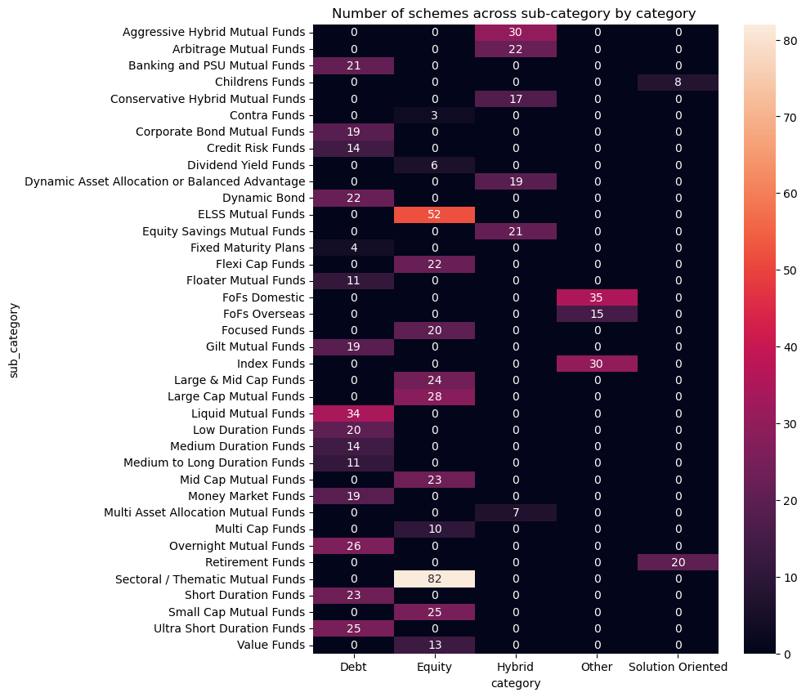

Findings:

* Most of the debt funds is Liquid Mutual Funds
* Most of the Equity funds is Sectoral/Thematic
* Most of the funds in Hybrid category is Aggressive Hybrid Mutual funds
* Most of the Other category funds is FOFs domestic
* Solution Oriented fund includes only Retirement funds
* *# category wise returns*

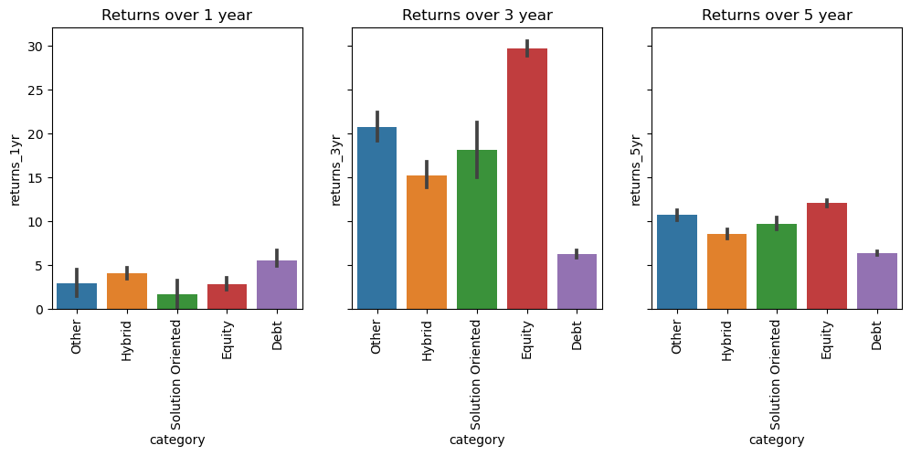

Findings

* Debt has been good in 1 year returns
* For 3 and 5 year Equity has outperformed other categories.

## Analysis of sub category

*# distribution of sub category*

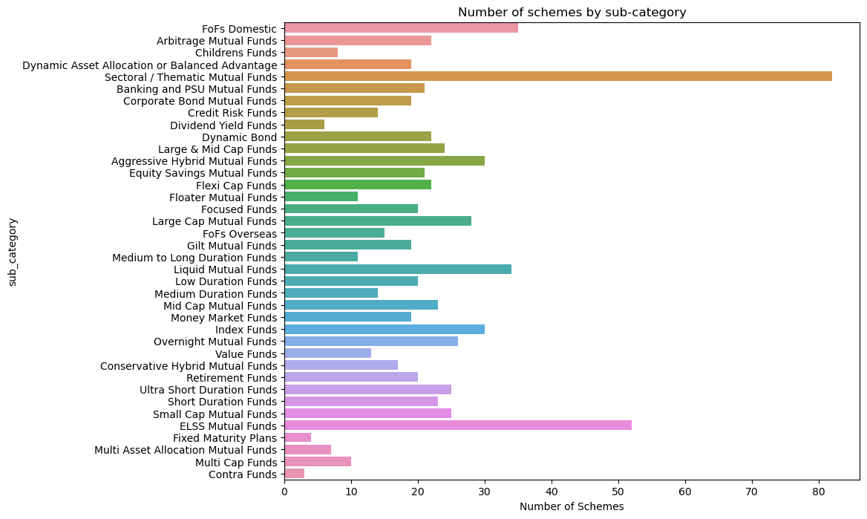

Findings

* Most popular sub-category are Sectoral/Thematic and ELSS Mutual Funds
* *# returns of debt category and various sub category over 1 year, 3 year, 5 year*

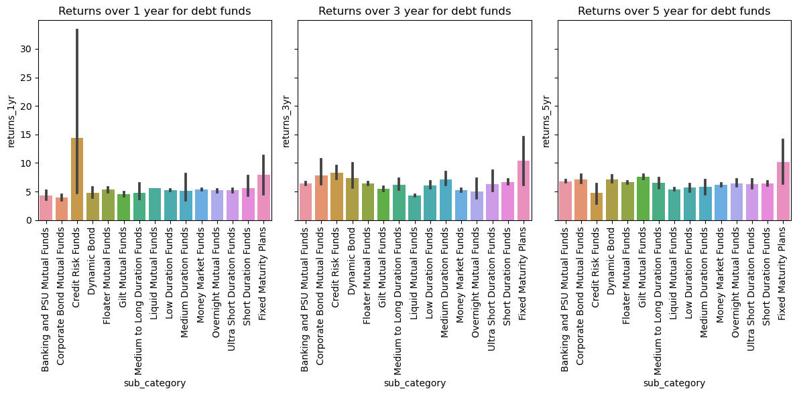

Findings

* Over 1 year best sub-category in Debt Category is Credit Risk Funds
* Over 3 year best sub-category in Debt Category is Fixed Maturity Plans
* Over 5 year best sub-category in Debt Category is Fixed Maturity Plans
* *# returns of equity category and various sub category over 1 year, 3 year, 5 year*

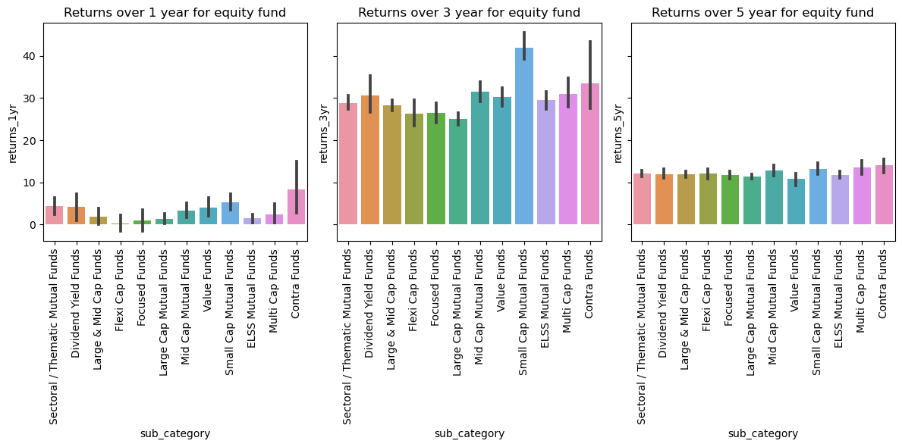

Findings

* Over 1 year best sub-category in Equity Category is Contra Funds
* Over 3 year best sub-category in Equity Category is Small Cap Funds
* Over 5 year returns do not differ much.
* *# returns of hybrid category and various sub category over 1 year, 3 year, 5 year*

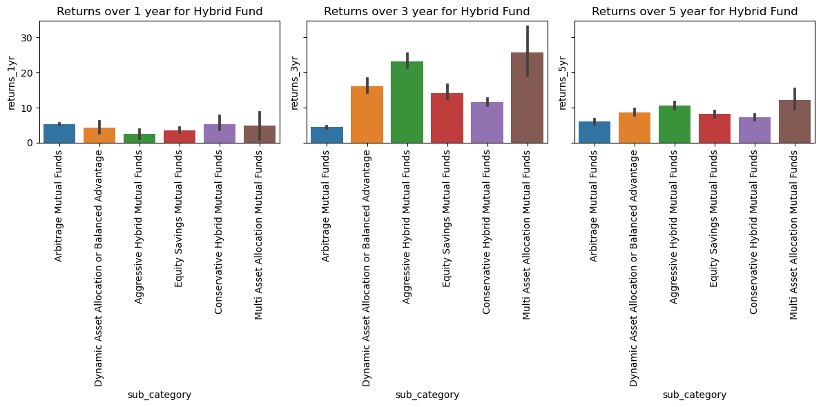

Findings

* Over 1 year best sub-category in Hybrid Category is Arbitrage and Conservative Funds
* Over 3 year best sub-category in Hybrid Category is Aggressive and Multi Asset Allocation
* Over 5 year best sub-category in Hybrid Category is Aggressive and Multi Asset Allocation
* *# returns of other category and various sub category over 1 year, 3 year, 5 year*

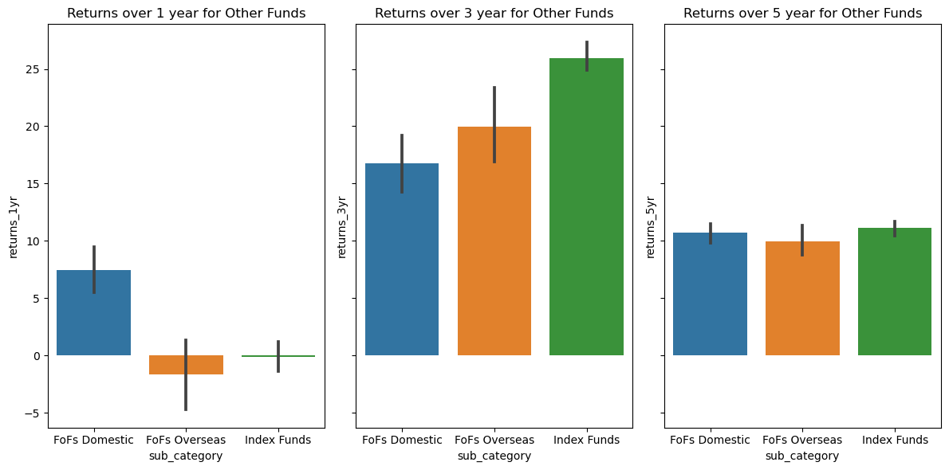

Findings

* Over 1 year best sub-category in Other Category is FoFs Domestic, also FoFs overseas has given negative return
* Over 3 year best sub-category in Other Category is Index Funds
* Over 5 year best sub-category in Other Category is FoFs Domestic and Index Funds
* *# returns of solution oriented category and various sub category over 1 year, 3 year, 5 year*

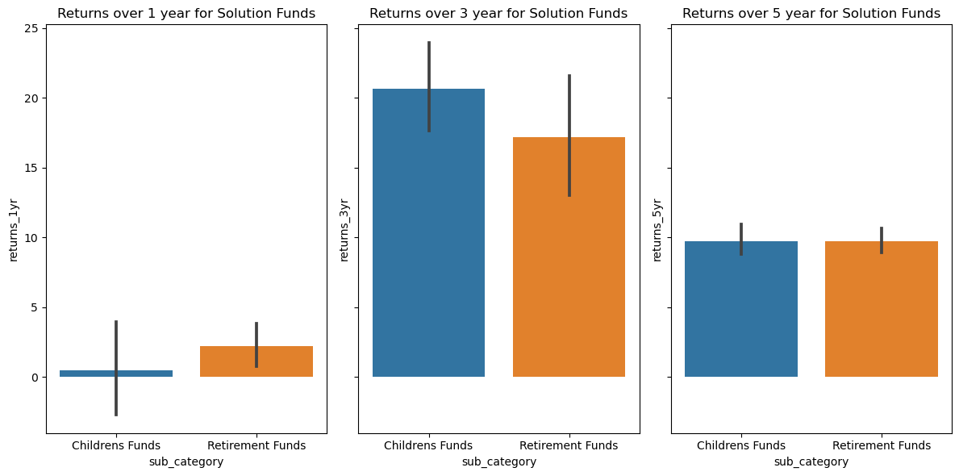

Findings

* Over 1 year best sub-category in Solution Category is Retirement Funds
* Over 3 year best sub-category in Solution Category is Children Funds
* Over 5 year returns do not differ much

## Analysis on alpha

Alpha is defined as the excess return of the mutual fund over the benchmark return, on a risk-adjusted basis.

Risk-adjusted basis means we need to –

Calculate the difference between the mutual fund returns and the risk-free return. Calculate the difference between the benchmark return and the risk-free return, multiply this by the beta. Take the difference between 1 and 2

Mathematically,

Alpha = (MF Return – riskfree return) – (Benchmark return – riskfree return)*Beta

Lets put this in context with an example. Assume a certain fund gives you a return of 10%, its benchmark returns for the same duration is 7%. The beta of the fund is 0.75. What do you think the alpha assuming the risk-free rate is 4%?

Let’s apply the for formula and check –

Alpha = (10%-4%)-(7%-4%)*0.75 = 6% – 2.25% = 3.75% or 0.0375

As you can see, the alpha is not just the difference between the fund and its benchmark, which if true, the alpha would have been – 10% – 7% =3%

But rather, the alpha is 3.75%.

The fund has managed to generate a 10% return compared to the Index’s 7% while managing to stay significantly less volatile (remember beta is just 0.75). Hence we are rewarding the fund for its good behaviour or less volatile behaviour. Therefore the alpha is 3.75% as opposed to just 3%.

Now, imagine the same fund, with the same returns, but the beta is 1.3 instead of 0.75. What do you think is the alpha? By now, you should guess that since the beta is high, the fund gets penalised for its erratic behaviour. Therefore the alpha should be lower.

Let us see if the numbers agree to this thought.

Alpha = (10%-4%)-(7%-4%)*1.3 = 6% – 3.9% = 2.1%

See that? While the returns remain the same, thanks to beta, the alpha is significantly lesser on a risk-adjusted basis.

To conclude, alpha is the excess return of the fund over above the benchmark returns. Alpha is a risk-adjusted. The fund is rewarded if the returns are generated by keeping a low-risk profile and penalized for being volatile.

By now, you must have realized that volatility plays an important role in measuring mutual funds performance. Beta is a measure of volatility; it tells us how risky the fund is when compared to its benchmark. Beta is a relative risk and does not reveal the fund’s inherent risk.

The inherent risk of a fund is revealed by the ‘Standard Deviation’ of the fund.

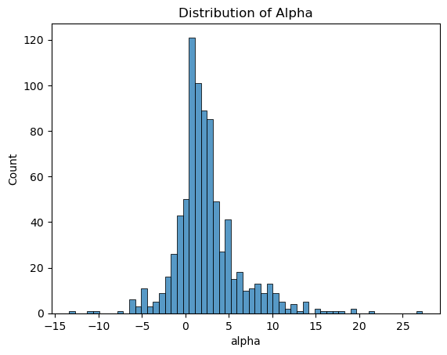

*# high alpha value has higher returns*

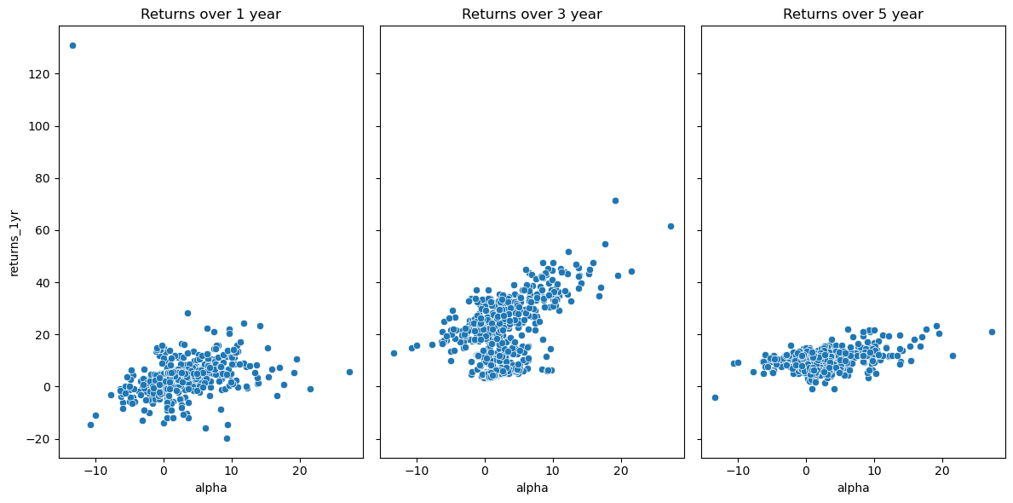

Findings

* Returns are higher for high Alpha
* *# alpha vs category*

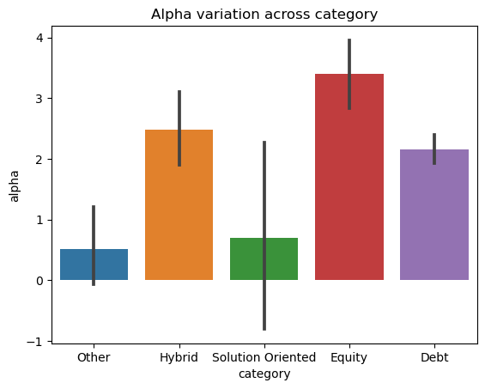

Findings

* Equity has highest Alpha
* *# alpha vs risk*

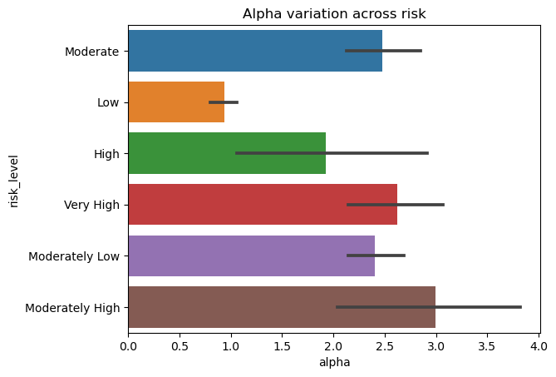

Findings

* Moderately high risk has high Alpha
* *# alpha vs rating*

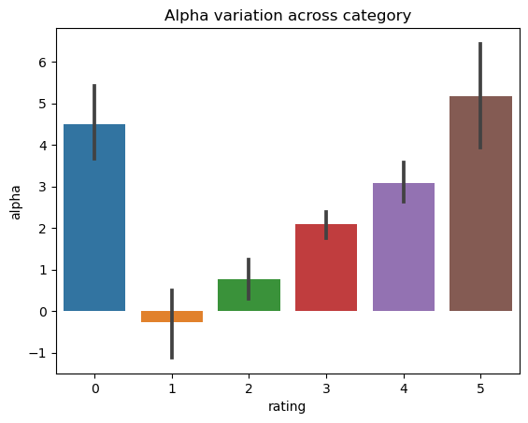

Finding

* 5 Rated fund has high Alpha
* Again since 0 rated fund has mostly Equity category and we have seen Equity category has high Alpha

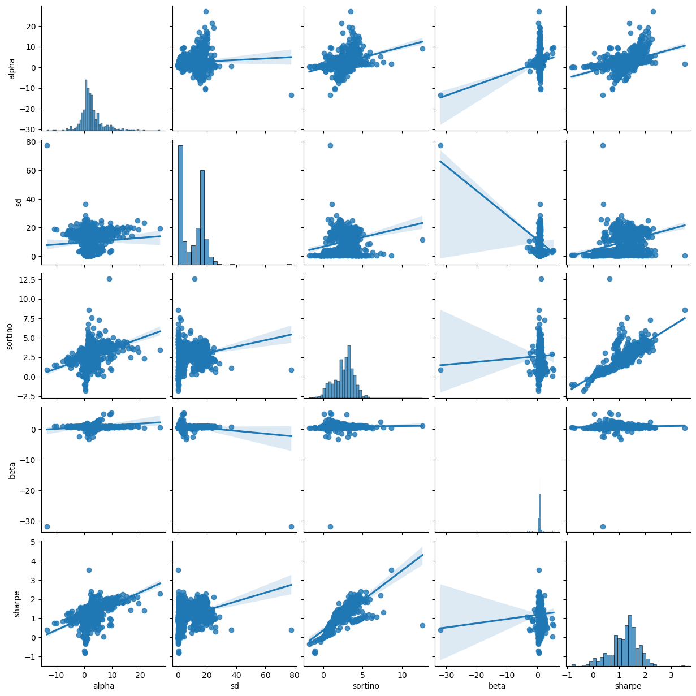

Findings

* Sharpe and Alpha are positively correlated.
* Sortino and Sharpe are positively correlated.
* Sortino and Alpha are positively correlated.

## Analysis of Standard deviation (sd)

The standard deviation of a stock or a mutual fund represents the riskiness of the stock or the mutual fund. Higher the standard Deviation, higher is the volatility of the asset. Higher the volatility, higher is the risk.

For example consider these 2 funds - The SD of the small-cap fund is 23.95% while the long term equity is 19.33%, which implies that the small-cap fund is way riskier compared to the long term equity fund.

To put this context, if you invest Rs.10,000/- across funds at the same time, then by the end of the year the profit or loss can be anywhere in this range –

Loss = Investment * (1-SD)

Gains = Investment * (1+SD)

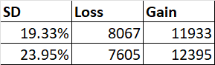

The larger the SD, the larger the possibility of loss or gains.

Generally speaking, the SD for mid and small-cap funds are higher compared to large-cap stocks.

Do note, volatility or Standard Deviation should not worry you. Markets are volatile, and equities are volatile, mutual funds are volatile; this is the very nature of markets. So if you can’t fathom watching your investment see-saw between gains and loss, then perhaps you should reconsider your investment decision in equities.

But if you do invest in equities, then you need to learn to manage volatility. There are two ways to deal with this beast called ‘Volatility’ –

* Diversify smartly (and not over diversify)
* Give your investment time

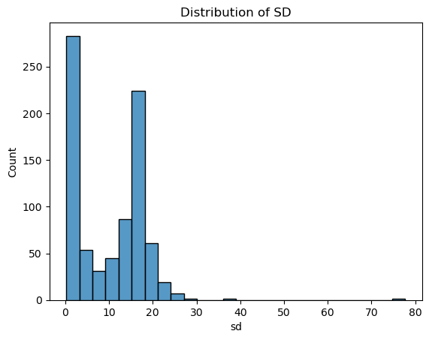

*# sd vs category*

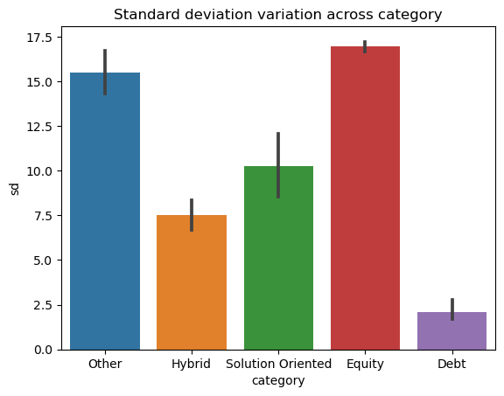

Findings

* Equity has high SD means it is more volatile
* Debt has less SD means it is less volatile.
* *# sd vs sub category*

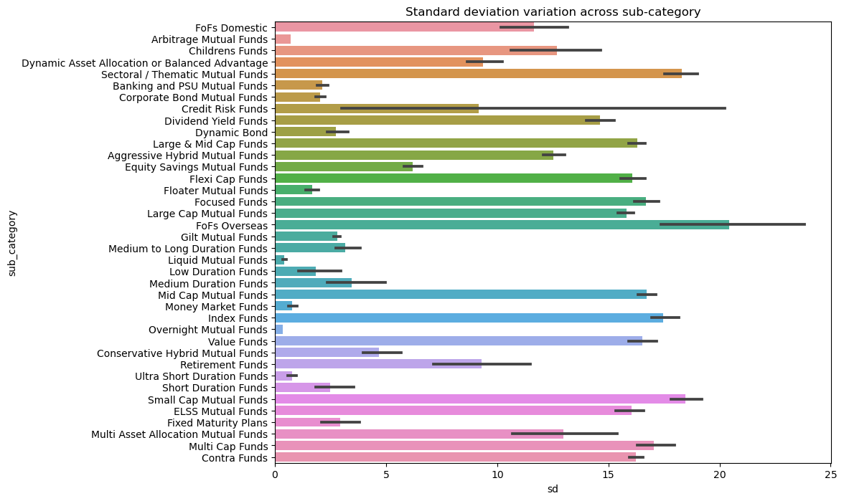

Findings

* FoFs Overseas has highest volatility and it should be invested for long duration.
* For short duration investment Liquid and Overnight funds are more suitable as they are less volatile.
* *# sd vs risk*

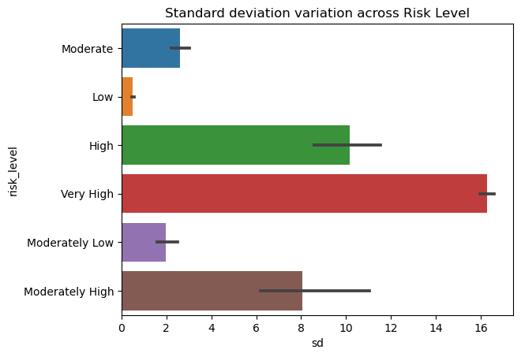

Findings

* Very High risk category has high SD
* *# sd vs rating*

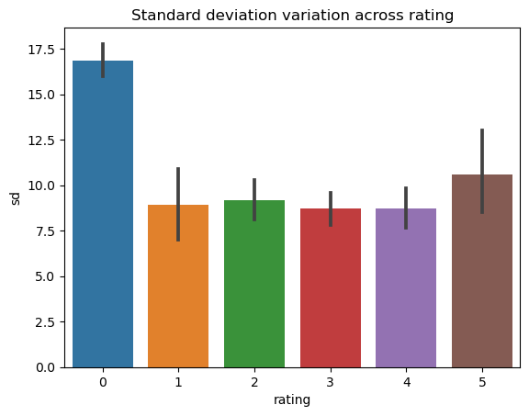

Findings

* Rating 0 and Rating 5 has most of the Equity Category hence higher SD

## Analysis of beta

Beta = Covariance between mutual fund and benchmark / Variance of benchmark index

A beta of 1 indicates that the mutual fund has the same level of volatility as the benchmark index. A beta of less than 1 indicates lower volatility, while a beta of greater than 1 indicates higher volatility.

For example, the Quant Small Cap Fund has a beta of 0.92, hence the fund is slightly less risky compared to its benchmark. I say slightly because it’s very close to 1. This implies, if Nifty Small Cap 250 Index falls by 1%, then Quant Small Cap Fund is expected to fall by 0.92%.

If the beta was 0.6 or 0.65, the fund is less risk or less volatile compared to its benchmark. Why? Because if Nifty Small Cap 250 Index falls by 1%, then Quant Small Cap Fund is expected to fall by only 0.65% and not 0.95%.

This is what I mean by ‘relative risk’; it gives us a perspective of how risky the fund is compared to its benchmark.

When you are looking at the Beta of a stock or an MF, it is very important to recognize the fact that the beta is a measure of relative risk, it tells us how risky the stock or MF is compared to its benchmark. Beta is not an indicator of the inherent risk of the stock or MF.

To put this in context, think about it this way, Ferrari is faster compared to a BMW, this comparison is like the beta. We measure the speed of car one against car two. But does this give you any indication of how fast the Ferrari is? Not really.

Likewise, while beta gives us a perspective of the relative riskiness of an asset, it does not give us the absolute or the inherent risk of the asset itself.

By now, you must have built your perception of beta. Let me ask you this – if a mutual fund has a high beta, do you think it is bad?

Well, the good, bad, ugly part of beta depends on another metric called the ‘Alpha’.

To know more about Mutual Fund Metrics - refer to [Zerodha varsity](https://zerodha.com/varsity/chapter/mutual-fund-risk-metrics/)

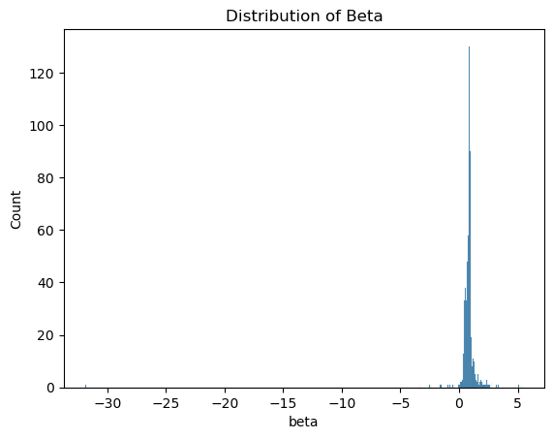

*# category vs beta*

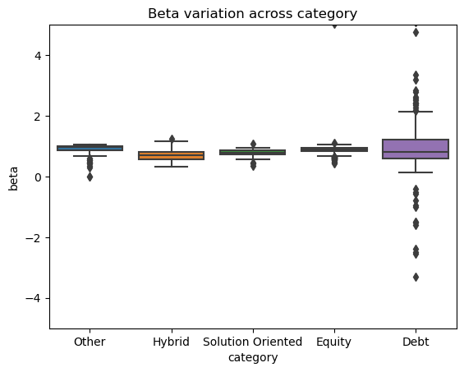

Findings

* Debt funds has negative beta it means when market will go down then returns for these funds will increase and vice versa.
* *# equity mutual funds has high beta*

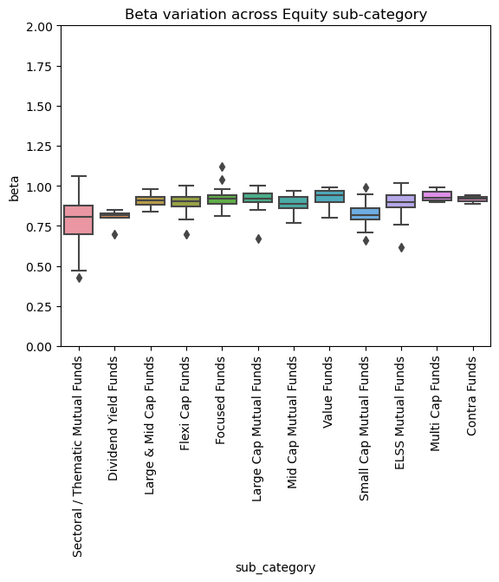

*# debt mutual funds has high beta variations*

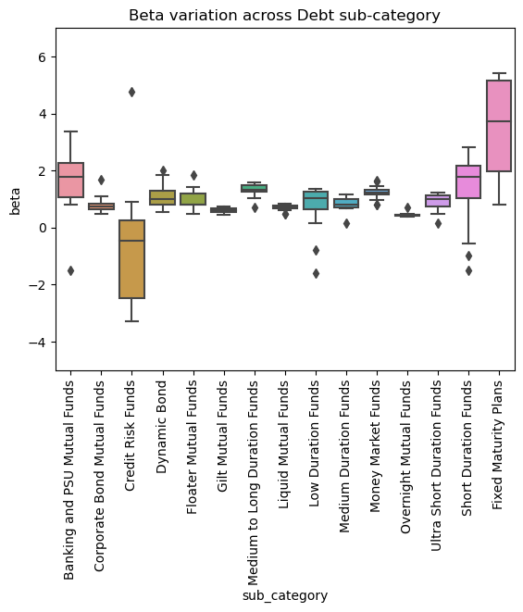

*# beta vs risk*

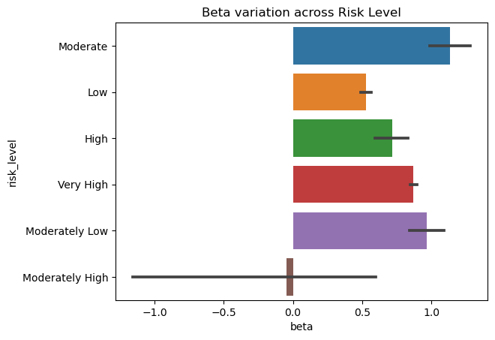*# beta vs rating*

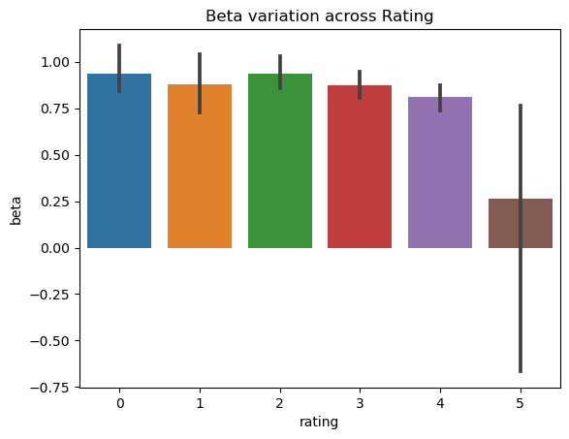

## Analysis on Sharpe

Assume, there are two large-cap funds -Fund A and Fund B. Here is how they have performed in terms of returns –

Fund A – 14%

Fund B – 16%

Which of the two funds are better? Well, Fund B has a higher return, so without a doubt, Fund B is a better fund.

Now, consider the following –

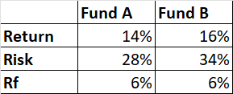

Rf is the risk-free return. Along with the fund’s return, I’ve also stated the standard deviation/volatility/risk of the two funds. Now, which of the two funds do you think is better?

I guess it gets a little complex to figure out which these two funds are better given that we have to evaluate them on two parameters, i.e. both the risk and return.

Ignoring the risk, purely on a return basis, Fund B is better. Ignoring the return, purely on a risk basis, Fund A is better. But in reality, you cannot isolate risk and reward; you need to factor in both these and figure out which of these two are better.

The Sharpe Ratio helps us here. It bundles the concept of risk, reward, and the risk-free rate and gives us a perspective.

Sharpe ratio = [Fund Return – Risk-Free Return]/Standard Deviation of the fund

Lets apply the math for Fund A –

= [14% – 6%] / 28%

= 8%/28%

= 0.29

The number tells us that the fund generates 0.29 units of return (over and above the risk-free return) for every unit of risk undertaken.Naturally, by this measure, the higher the Sharpe ratio, the better it is as we all want higher returns for every unit of risk undertaken.

Lets see how this turns out for Fund B –

= [16% – 6% ] / 34%

= 10% / 34%

= 0.29

So it turns out that both the funds are similar in terms of their risk and reward perspective. And there is no advantage of choosing Fund A over Fund B.

Do note, Sharpe ratio considers only price based risk. It does not consider credit or interest rate risk. Hence, there is no point looking at the Sharpe ratio for debt funds.

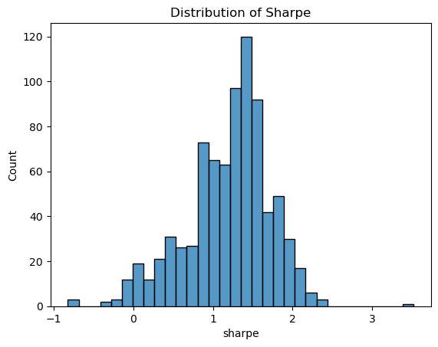

*# category vs sharpe*

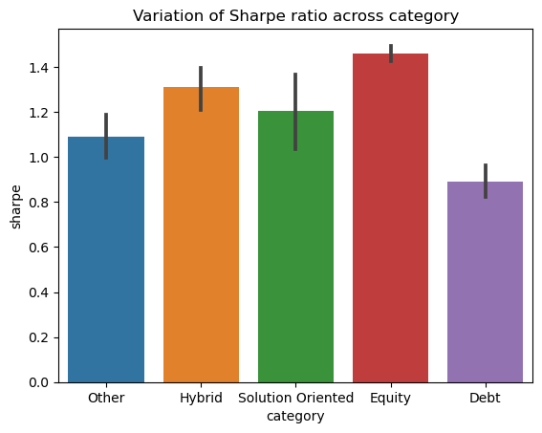

Findings

* Equity fund has highest Sharpe Ratio
* *# sharpe vs risk*

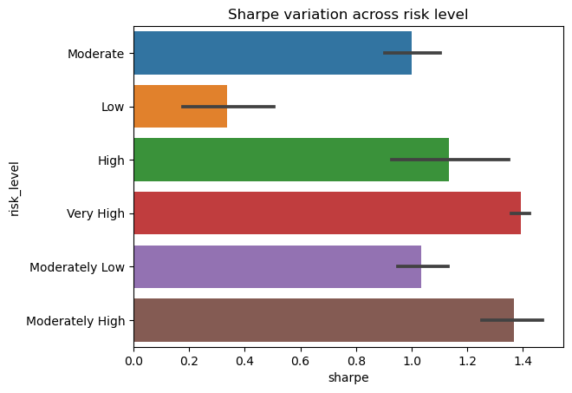

Findings

* Very High and Moderately High has somewhat same average Sharpe
* *# sharpe vs rating*

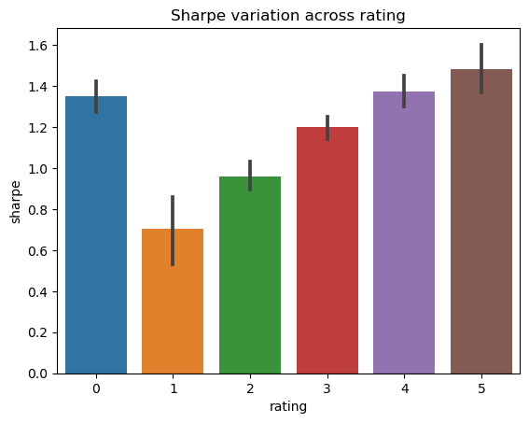

Findings

* As rating increases sharpe ratio also increases

## Analysis on Sortino

The Sortino’s ratio is an improvisation over the Sharpe Ratio, wherein the denominator has only the negative returns or the ‘downside risk’, is considered.

Hence, the Sortino’s Ratio is –

= [Fund Return – Risk-Free Return]/Downside Risk

The objective of Sortino’s ratio is to estimate the excess return adjusted for only the downside risk. Like the Sharpe ratio, higher the Sortino’s ratio, better it is.

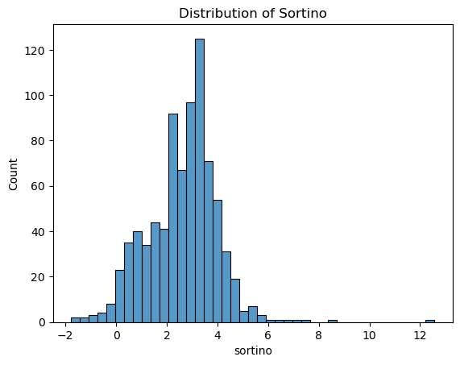

*# category vs sortino*

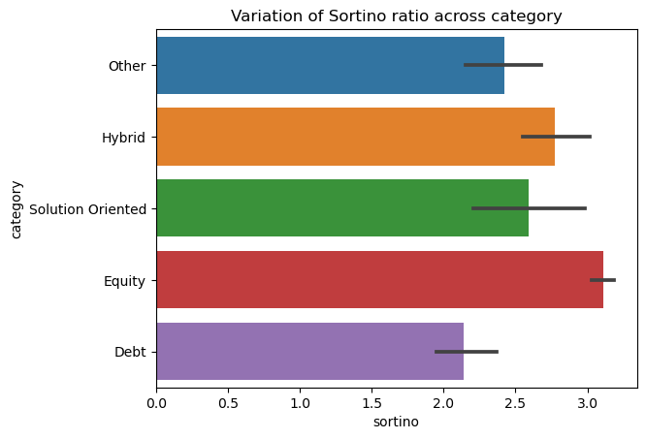

Findings

* Equity has highest Sortino
* *# sortino vs risk level*

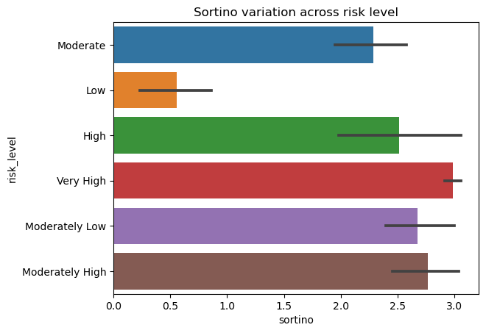

Findings

* Very High Risk category has high sortino

*# sortino vs rating*

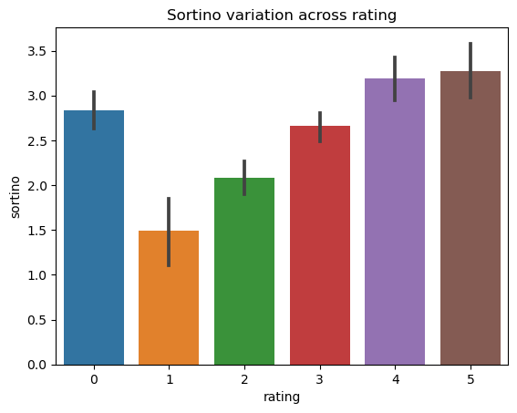

Finding:

* Rating and sortino are positively correlated

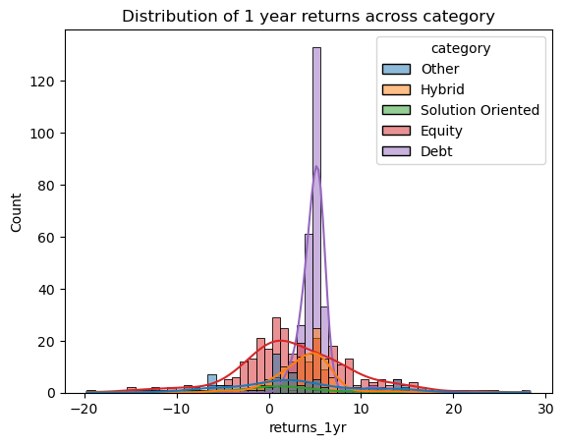

Findings

* For 1 year investment Debt fund has performed well. Other category may give negative returns as well.

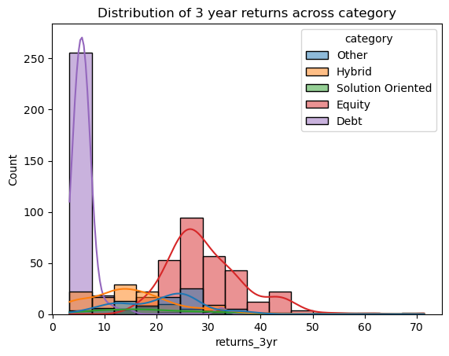

Findings

* Equity has outperformed every other category for 3 years performance.

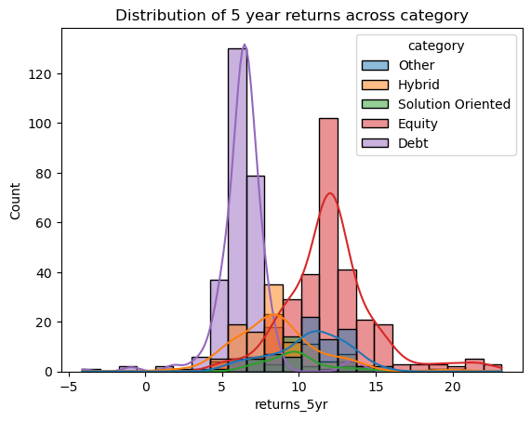

Findings

* Equity has outperformed every other category for 5 years performance.
* *# top schemes in each category and sub category in terms of returns earned*
* category_result

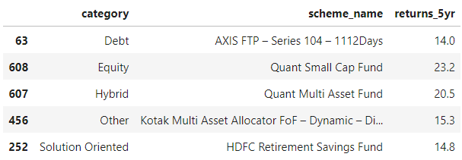

sub_catresult

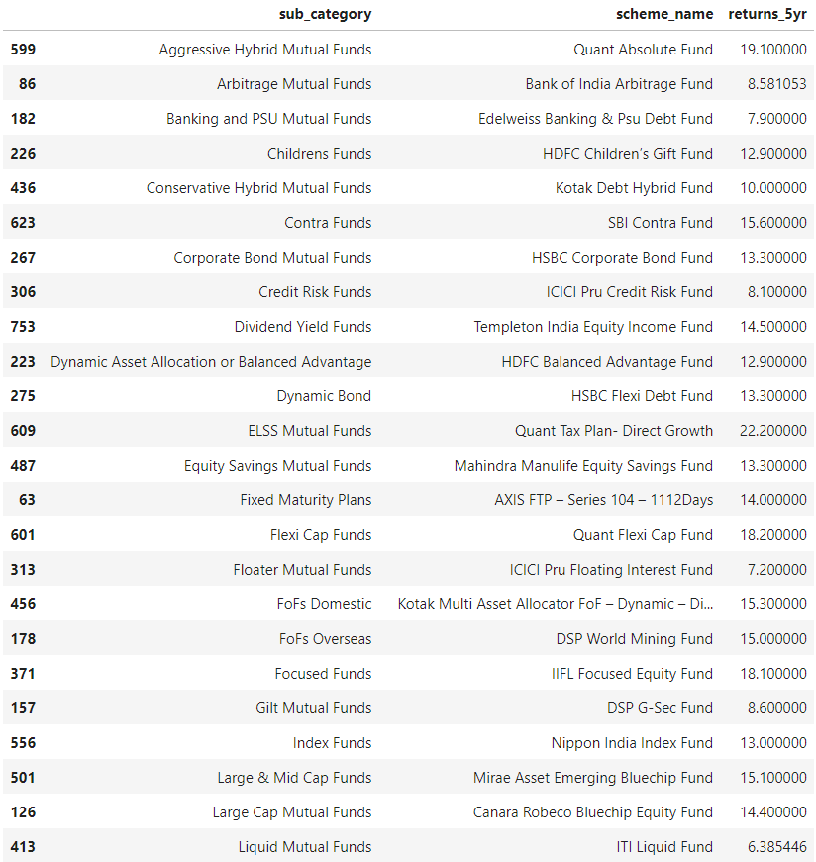

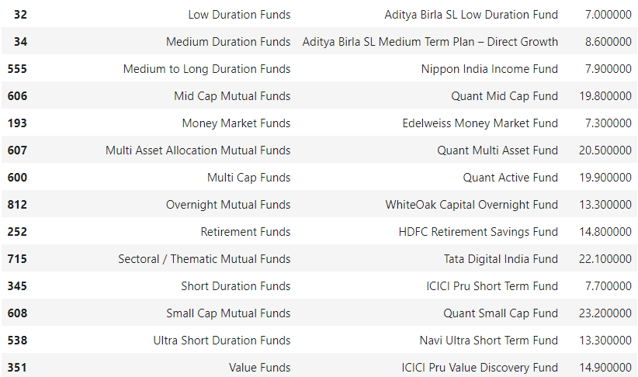

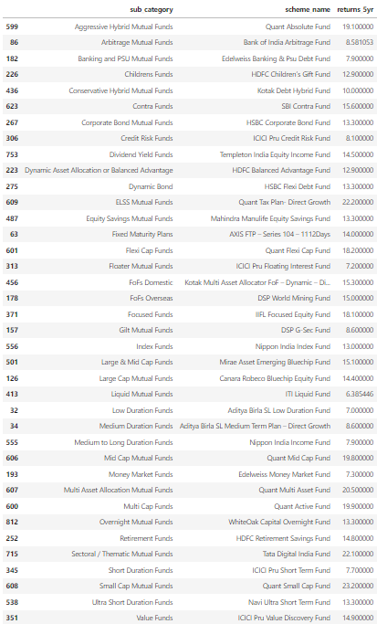

This notebook is for Educational purpose only and one should check with there advisor before investing in mutual funds.